Mentor Mr. Hà Việt Sơn

Team member

Nguyễn Bắc Giang

Nguyễn Thanh Thủy

Phạm Quốc Hoàng

Nguyễn Hoàng Nam

Nguyễn Đặng Thái Sơn

Vehicle insurance managerment

T2208E - SEMESTER 3 – TEAM 1



TABLE OF CONTENTS

I. Introduction 2

II. Objectives 2

III. Abstract 3

IV. Project Plan 4

V. Use Case 6

VI. Customer Requirement Specification. 8

VII. Requirements 10

VIII. Database Diagram 14

IX. Algorithms and Technology 16

X. UI/UX User Guide 20

XI. Developer’s Guide 56

XII. Check List 59

XIII. Acknowledgments 60

# Introduction

In today’s world computer plays an important role in each field. It has been used in various fields. In the current age every aspect of our life has been influenced by information technology. The main aim of this project is to add some attraction and gild in record keeping operation of Vehicle Insurance.

We use the computer technology in many ways, from visible to invisible, spectacular to routine, video games and special effect, electronic cameras etc.

The product entitled “automation” aim at automation of many processes of Vehicle Insurance. Current manual system that is employed is extremely laborious and quite in adequate it only makes the process more difficult and harder. Main purpose of this software should be to reduce the manpower, paperwork and provide the security from unauthorized access. It should also help in producing difficult kinds of report required for different managerial aspects.

# Objectives

The objective of the system is to provide the facilities to all the people concerned with Vehicle Insurance. From the management point of view works can be done fast and more accurately as compared to existing manual system. From the customer’s point of view, he can get immediate services without any kind of wasting of time whereas from the user’s point of view all kinds of transitions can be done in very easy and efficient manner. The system also provides many kinds of reports generation facility. Our main objectives for developing this project are giving below.

* DATA SECURITY.
* REDUCED PAPER WORK.
* REDUCED MANPOWER.
* INCREASED OPERATIONAL EFFICIENCY.
* INCREASED ACCURACY AND RELIABLITY.
* IMPORVE MORAL.
* REDUCE OPRATIONAL TIME

This project aims to develop a complete fully functional independent system with the intension of improving the productivity of the operations of company through speedy and accurate processing and efficient storage and retrieval of data. The basic aim behind this project to provide a complete solution that manages the records of vehicle insurance company.

# Abstract

The project aims to automate and improve the record-keeping operations of a Vehicle Insurance company. The current manual system is laborious and inadequate, making the process difficult and time-consuming. The objectives of the project include data security, reduced paperwork and manpower, increased operational efficiency, accuracy and reliability, improved morale, and reduced operational time.

The system consists of several modules, including login, customer information, vehicle information, estimate generation, insurance process, company billing policy, reports, company expenses, and claim details. These modules handle various aspects of the insurance process, such as customer and vehicle information management, estimate generation, policy records, billing, reporting, expenses tracking, and claim details maintenance.

The functional requirements involve developing an online insurance portal that allows customers to register, login, purchase policies online, initiate claims, and change passwords. The system also includes an admin login for employees to perform administrative functions, including policy and claim record management and generating reports.

The system aims to improve productivity through speedy and accurate processing, efficient data storage and retrieval, and providing various reports for analysis and decision-making. The generated reports include monthly policy sales, vehicle-wise analysis, claims report, policies due for renewals, and policies lapsed report.

Overall, the project aims to provide a comprehensive solution for managing the records of a vehicle insurance company, enhancing efficiency, and providing better services to customers.

# Project Plan

* Determine the project goals to be achieved - Project Goal.

The project aims to automate and improve the record-keeping operations of a Vehicle Insurance company.

* Determine project deliverable time – Project Deliverable.
  + Project Start Date: March 26, 2024
  + Project Evaluation: April 22, 2024
  + Project Submission Date: May 2, 2024
* Determine the project roadmap - Project Schedule.

1. Introduction

- Summarize the problem, difficulty, build ideas -> purpose of the topic

1. Plan

- Develop a project implementation plan through 4 sprints, 1 week each sprint. What tasks will each sprint need to do, and what is the goal at the end of the sprint?

- Assign tasks: which task - by whom - deadline

1. Analysis - Design

Describe the problem through learned diagrams such as:

- Stakeholders: role of each component in the system with a table of permissions based on role.

- Use-cases

- Flowchart: flow will be executed

- Process Diagram (sequence): thread will execute

- ERD: describes entities

1. Make a support plan for the project - Supporting Plans

- Human resource plan: Determine the role of individuals and organizations in the project, provide appropriate workload for each specific individual.

- Communication plan: Prepare documents to disseminate to all relevant parties about the project. Regularly announce project progress so everyone can stay informed.

- Risk management plan: Predict risks that may be encountered during project implementation and provide timely response measures. Some common risks include incorrectly estimating working time; Employees do not complete their work, difficulties in assigning workload...

1. Project implementation

- Task sheet: detailed functions that need to be done to complete the above flows. Each row includes: Function name - Description - Input – Output.

- Testcase: edit the task table, add Success/Fail column to report items that ran well or did not run well.

1. Technology used in the project

- Algorithms and technology used

- Requirements for server configuration and deployment technology

1. Results

Description of main functions of the system with screenshots

1. Conclusion & Development Direction

- What has been achieved, what has not been completed, difficulties and challenges... future project development directions.

# Use Case

Admin

Log in, Log out

Maintaining

Search

Monthly sell of policies

Vehicle wise analysis

Claims report

Policies due renewals

Policies lapsed report

Customer

Purchase the policy online

Payment

Initiate the claim

Admin

Log in, Log out

Maintaining

Search

Monthly sell of policies

Vehicle wise analysis

Claims report

Policies due renewals

Policies lapsed report

Customer

Change password

Log in, Log out

Purchase the policy online

Register

Payment

Initiate the claim

# Customer Requirement Specification.

There will be 3 types of users

* Guest
* Customer
* Admin

1. Guest

Guest users will be able to browse website, read about the information and see the products. But guest users will not be able to do shopping.

1. Customer
   * Register with the system
   * Name
   * Address
   * Phone Number
   * Customer can login with unique user name and password.
   * He can change the password.
   * Can purchase the policy online: For purchasing the policy online, he has to fill in the application form which would capture all the required information about the vehicle. On successful payment, copy of policy would be generated which customer can save for the records.
   * Initiate the claim by filling the claim form.
2. Admin

* Employee will be admin who can login with admin user name and password.
* He can perform all the admin functions as maintaining the policy records, claim records, payment schedules etc
* Following reports needs to be generated
  + Monthly sell of policies
  + Vehicle wise analysis
  + Claims report
  + Policies due renewals
  + Policies lapsed report

1. The site should have menu categorising required functionalities

* About us
* Types of insurance
* Testimonials
* Site map
* Contact us

1. There should be a categorized menu.
2. Data should be properly paginated while showing the products.
3. The site should have a professional look and feel.

# Requirements

**MODULE DESCRIPTION**

## **5.1) MODULE 1: LOGIN**

Login module allows only authorized user to access the system.

## **5.2) MODULE 2: CUSTOMER INFORMATION**

In this module, system stores customer’s information in database.

***Customer Record***

This table contains the following information:

*Fields Description*

**Customer ID Numeric**

**Customer Name Character**

**Customer ADD Character**

**Customer phone number Numeric**

## **5.3) MODULE 3: VEHICLE INFORMATION**

In this module, system stores vehicle’s information in database.

***VEHICLE Information***

This table contains the following information.

***Fields Description***

**Vehicle Id Numeric**

**Vehicle name Character**

**Vehicle’s owner name Character**

**Vehicle model Character**

**Vehicle version Character**

**Vehicle Rate Numeric**

**Vehicle body number Character**

**Vehicle engine number Character**

**Vehicle number Numeric**

## **5.4) MODULE 3: ESTIMATE**

This module generates estimates for the Vehicle insurance enquired by customer. Estimate module will have customer’s information from Customer Information Module 2.

***Estimate***

**This table contains the following information**

***Fields Description***

**Customer ID Numeric**

**Estimate number Numeric**

**Customer name Character**

**Customer phone number Numeric**

**Vehicle name Character**

**Vehicle model Character**

**Vehicle Rate Numeric**

**Vehicle warranty Character**

**Vehicle policy type Character**

## **5.5) MODULE 4: INSURANCE PROCESS**

This module, customer takes vehicle insurance from company. System maintains the records in database. This module is related to Customer Information Module 2.

***Customer policy Records***

**This table contains the following information**

***Fields Description***

**Customer ID Numeric**

**Customer Name Character**

**Customer ADD Character**

**Customer phone number Numeric**

**Policy number Numeric**

**Policy date Character**

**Policy duration Numeric**

**Vehicle number Numeric**

**Vehicle name Character**

**Vehicle model Character**

**Vehicle version Character**

**Vehicle Rate Numeric**

**Vehicle warranty Character**

**Vehicle body number Character**

**Vehicle engine number Character**

**Customer Add Prove Character**

## **5.6) MODULE 5:** **COMPANY BILLING POLICY**

This module, generate the customer bill and store its payment detail with date, bill number and car information policy number. This module is related to module 2.

***Customer Billing Information***

**This table contains the following information**

***Fields Description***

**Customer ID Numeric**

**Customer Name Character**

**Policy number Numeric**

**Customer Add Prove Character**

**Customer phone number Numeric**

**Bill No. Numeric**

**Vehicle name Character**

**Vehicle model Character**

**Vehicle Rate Numeric**

**Vehicle body number Character**

**Vehicle engine number Character**

**Date Character**

**Amount Numeric**

## **5.7) MODULE 8: REPORT**

In this module, generate the report of company monthly insurance and income and customer report.

## **5.8) MODULE 9: COMPANY EXPENSES**

In this module, store the showroom expenses. Expenses type, expenses amount, expenses date.

***Company Expenses***

**This table contains the following information**

***Fields Description***

**Date of Expense Character**

**Type of Expense Character**

**Amount of Expense Numeric**

## **5.9) MODULE 10: CLAIM DETAILS**

**In this module the details of the claims initiated and approved are maintained.**

***Claim Details***

**This table contains the following information**

**Fields Description**

**Claim Number Numeric**

**Policy Number Numeric**

**Policy Start Date Character**

**Policy End Date Character**

**Customer Name Character**

**Place of accident Character**

**Date of accident Character**

**Insured amount Numeric**

**Claimable amount Numeric**

# Database Diagram

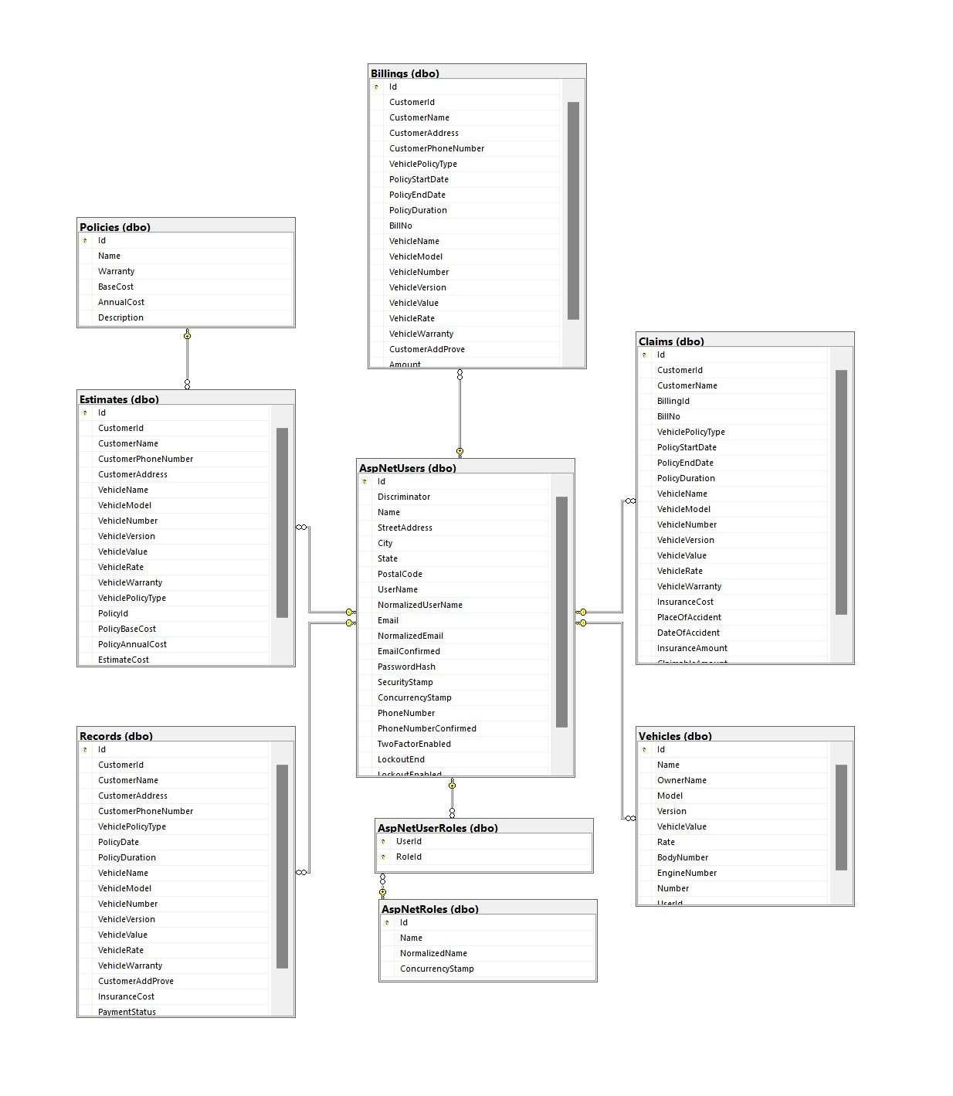

The image depicts a detailed database diagram showcasing the components and processes involved in managing data within a database management system.

The diagram includes several labeled elements, each representing a specific aspect of the database system. These elements are interconnected by arrows, illustrating the flow of data and processes between them.

Some key components visible in the diagram are:

* Data Entry: This component represents the process of entering data into the database system. It could involve user interfaces or automated mechanisms for data input.
* Data Validation: This component focuses on validating the entered data to ensure its accuracy and adherence to predefined rules or constraints. It may involve checking data types, formats, or applying business rules.
* Data Storage: This element represents the storage mechanism where the data is stored within the database system. It could include tables, files, or other data storage structures.
* Data Retrieval: This component refers to the process of retrieving specific data from the database based on criteria or queries. It involves accessing and extracting data from the storage component.
* Data Manipulation: This element represents the operations performed on the data stored in the database. It can include actions like updating, deleting, or modifying records based on user requirements.
* Data Analysis: This component focuses on analyzing the stored data to gain insights or generate reports. It may involve applying statistical techniques, generating charts or graphs, or running complex queries to extract meaningful information.

The arrows connecting these components indicate the flow of data and processes between them. They represent the sequence and relationships between the different elements within the database management system.

Overall, the database diagram provides a detailed representation of the components and processes involved in managing data within the database management system, illustrating the data flow and relationships between the various components.

# Algorithms and Technology

1. Vehicle insurance calculation formula

(The total cost to pay when purchasing Insurance will be based on the actual value of the vehicle * fee rate, in which:

Actual value of the car = minimum remaining ratio of the minimum quality of the car after being put into use (vehicle rate) * new car price.

The remaining minimum percentage of the vehicle's quality after being put into use (vehicle rate) is determined:

* Newly purchased car: 100% of value
* Vehicle used 1 - 3 years: 85% value
* Vehicle used 3 - 6 years: 70% value
* Vehicles used 6 - 10 years: 55% value
* Vehicles used over 10 years: value 40%

The fee rate is calculated as follows:

* Fee rate = Basic rate (basic range) + additional option fee rate (extended range)
* According to insurance consultants, the basic rate and additional fee options are clearly defined charges in the hazardous compound package. And normally, this fee will range from 1.5% - 2%/year depending on the definition of each hazardous material supplier.)

Based on the information about vehicle insurance we have researched, we have come up with our own vehicle insurance calculation formula:

* Actual insurance price = Basic insurance package price + Vehicle value * Vehicle rate * Number of years the vehicle has been used * Fee rate

Claim calculation formula:

* Claim fee = Actual insurance price * Vehicle rate

1. Search

$('#input-search').on('keyup', function() {

var rex = new RegExp($(this).val(), 'i');

$('.searchable-container .items').hide();

$('.searchable-container .items').filter(function() {

return rex.test($(this).text());

}).show();

});

The JavaScript code snippet is using jQuery to perform a search operation on elements with the class "searchable-container" and the class "items".

The code starts by selecting the elements with the class "searchable-container" and then filters them using the `filter()` function. Within the `filter()` function, a test is performed on each element's text content using the regular expression pattern defined by the variable `rex`. The `rex.test($(this).text())` statement checks if the text content of the current element matches the regular expression pattern.

If a match is found, the element is shown by using the `show()` method. This will make the filtered elements visible on the webpage.

1. Hashing

These mathematical functions take input, called a key, and use it to calculate a fixed-size character string called a hash value. Hashing algorithms transform random-sized data into information that is of a fixed-length value. We use hashing algorithms to perform storage, retrieval, or comparisons in cases where we need to:

* Hash passwords
* Create digital signatures
* Perform data integrity verification

1. MVC ASP.NET 8.0

MVC is a design pattern used to decouple user-interface (view), data (model), and application logic (controller). This pattern helps to achieve separation of concerns. Using the MVC pattern for websites, requests are routed to a Controller that is responsible for working with the Model to perform actions and/or retrieve data. The Controller chooses the View to display and provides it with the Model. The View renders the final page, based on the data in the Model.

The ASP.NET Core MVC framework is a lightweight, open source, highly testable presentation framework optimized for use with ASP.NET Core. ASP.NET Core MVC provides a patterns-based way to build dynamic websites that enables a clean separation of concerns. It gives you full control over markup, supports TDD-friendly development and uses the latest web standards.

ASP.NET gives you a powerful, patterns-based way to build dynamic websites using the MVC pattern that enables a clean separation of concerns. ASP.NET supports many database engines including SQLite, SQL Server, MySQL, PostgreSQL, DB2 and more, as well as non-relational stores such as MongoDB, Redis, and Azure Cosmos DB.

1. Database Microsoft SQL Server

Microsoft SQL Server is a relational database management system. As a database server that stores and retrieves data as requested by other software applications on the same computer or a remote computer using the client-server model. Microsoft provides APIs to access SQL Server over the internet as a web service.

1. JavaScript

* Bootstrap v4.3.1
* jQuery v3.4.1
* Owl Carousel v2.3.4

1. Software

* Visual Studio .Net / ASP
* Microsoft SQL server management studio
* Microsoft Azure
* Jira

Jira is an agile project management tool that supports any agile methodology, be it scrum, kanban, or your own unique flavor. From agile boards, backlogs, roadmaps, reports, to integrations and add-ons you can plan, track, and manage all your agile software development projects from a single tool.

* Zalo, Discord

# UI/UX User Guide

Users open browser and go to the website:

<https://carinsurancemanagerweb20240415190003.azurewebsites.net/>

Guests will be able to browse website, read about the information and see the products. But guests will not be able to do shopping.

1. Home Page

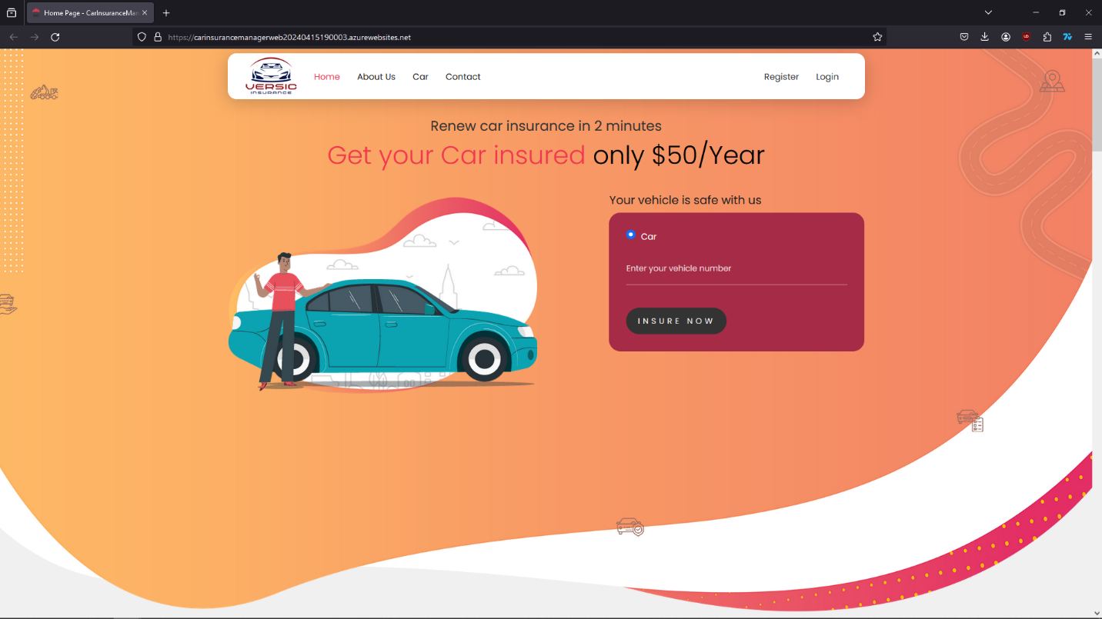

Guests can quickly go to register or log in site by filling out the form and then click the “Insure now” button or keep browsing website.

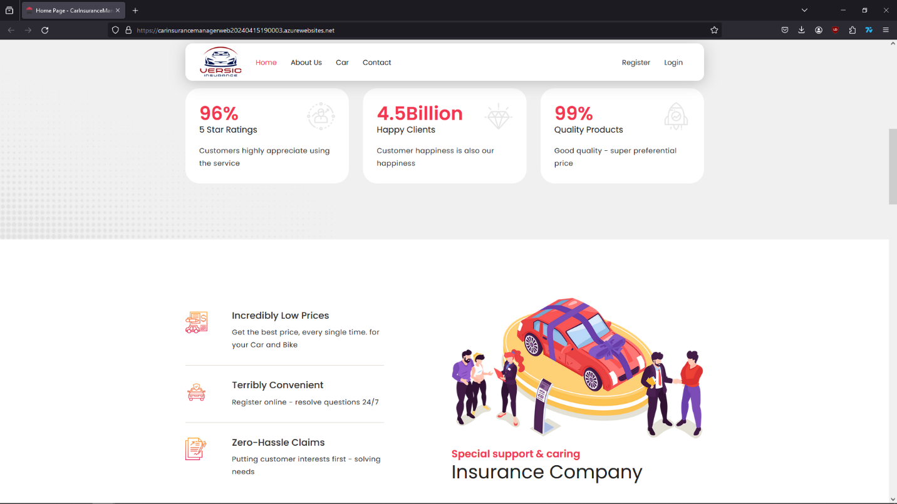

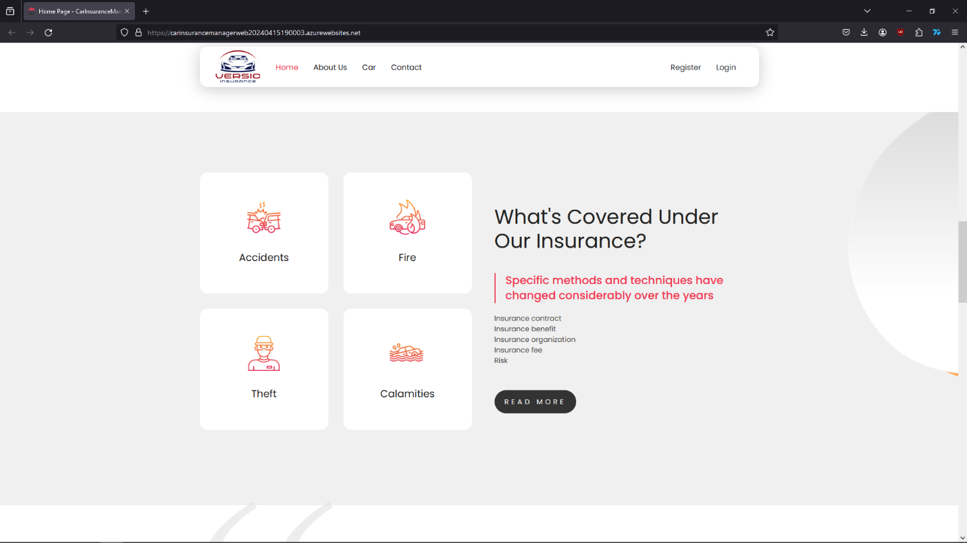

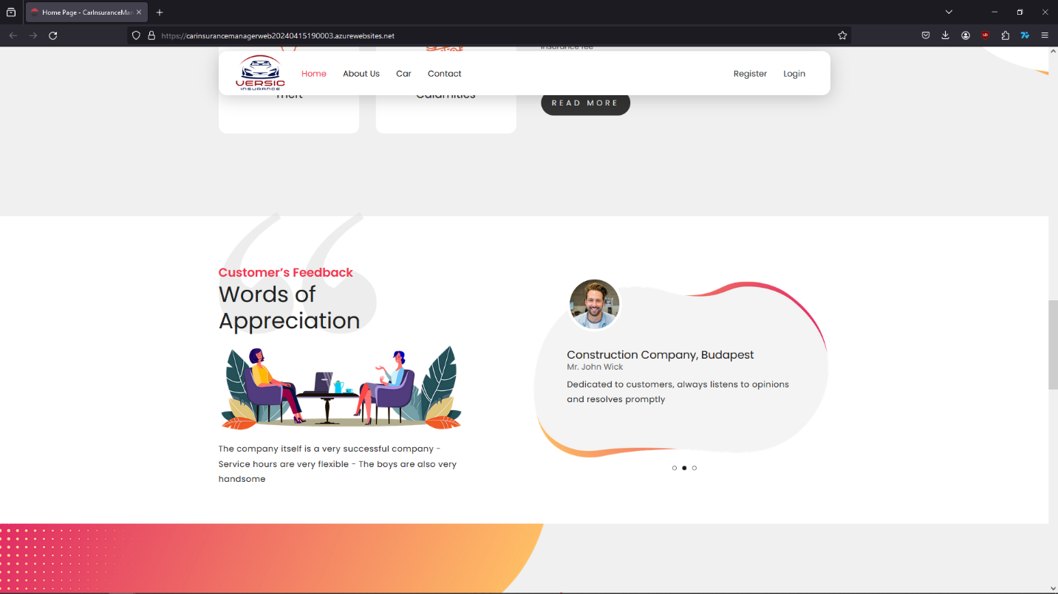

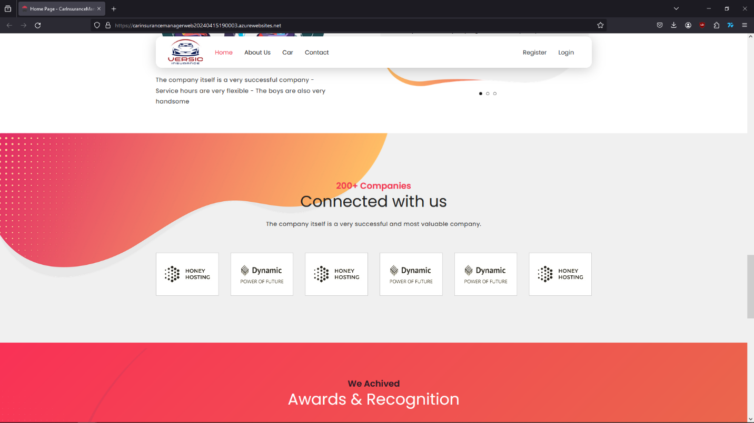

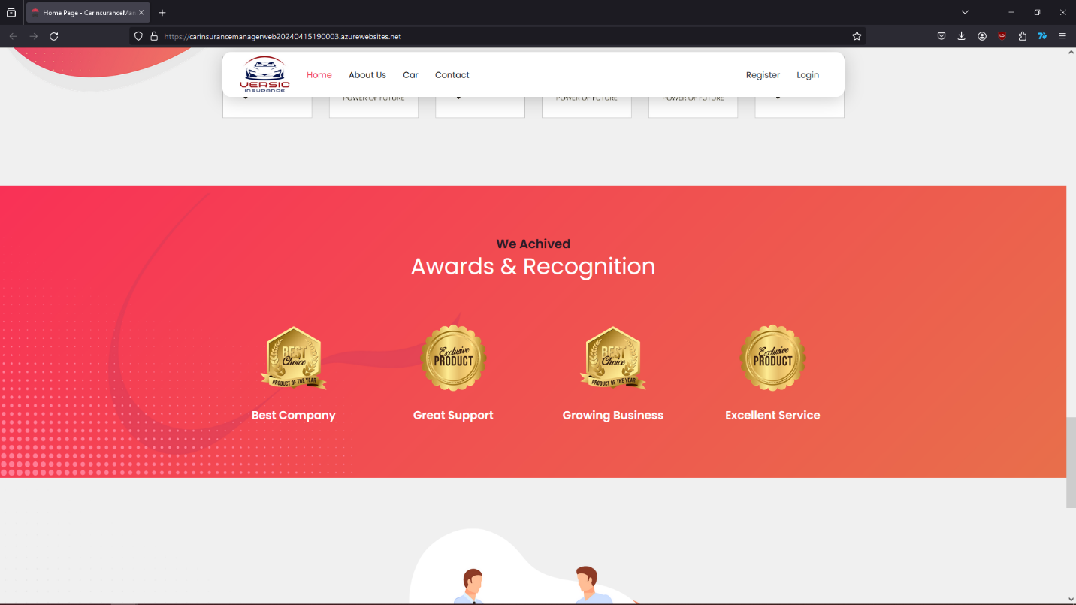

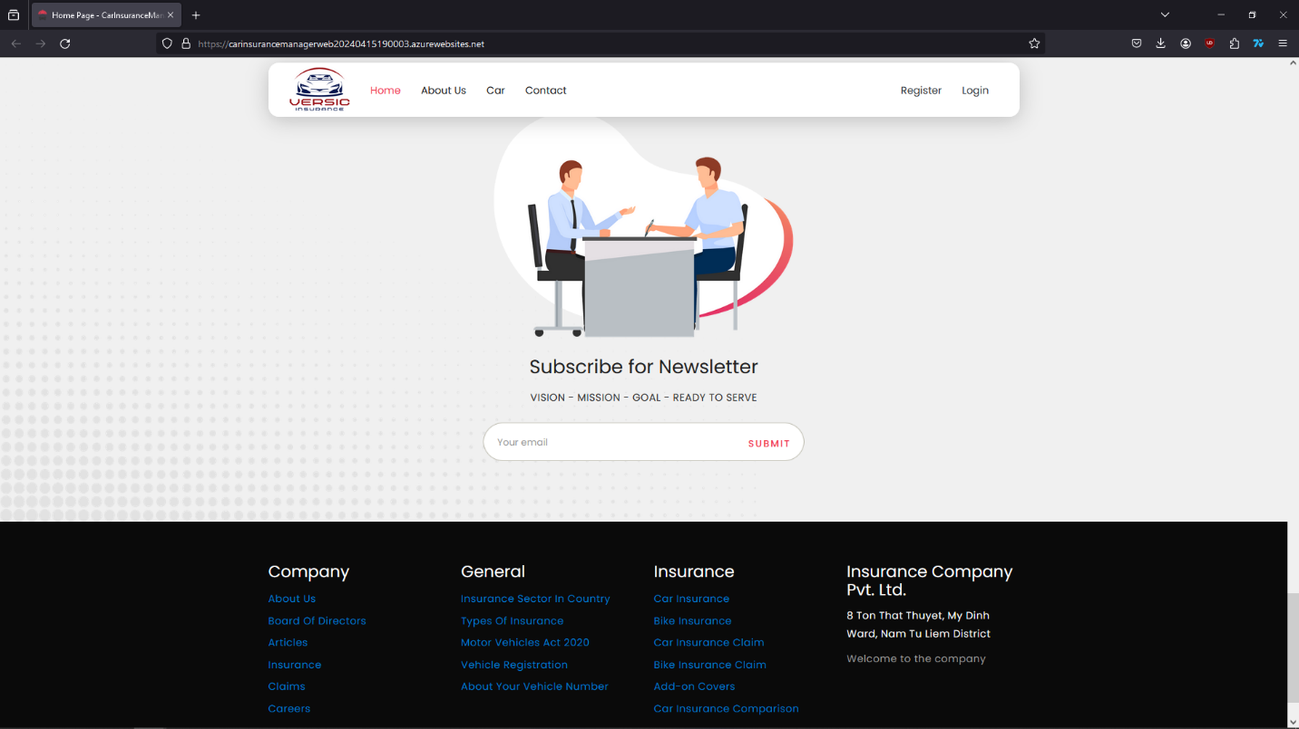

1. About Us

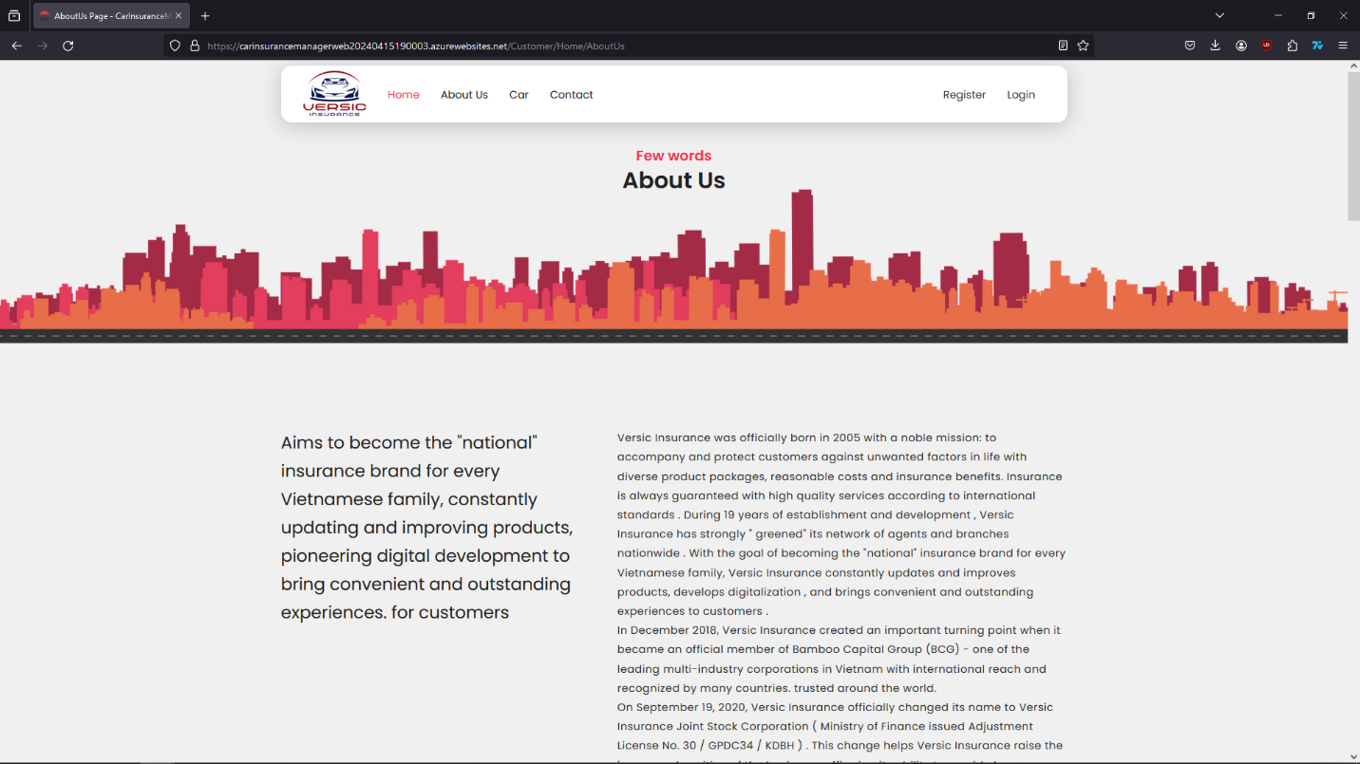

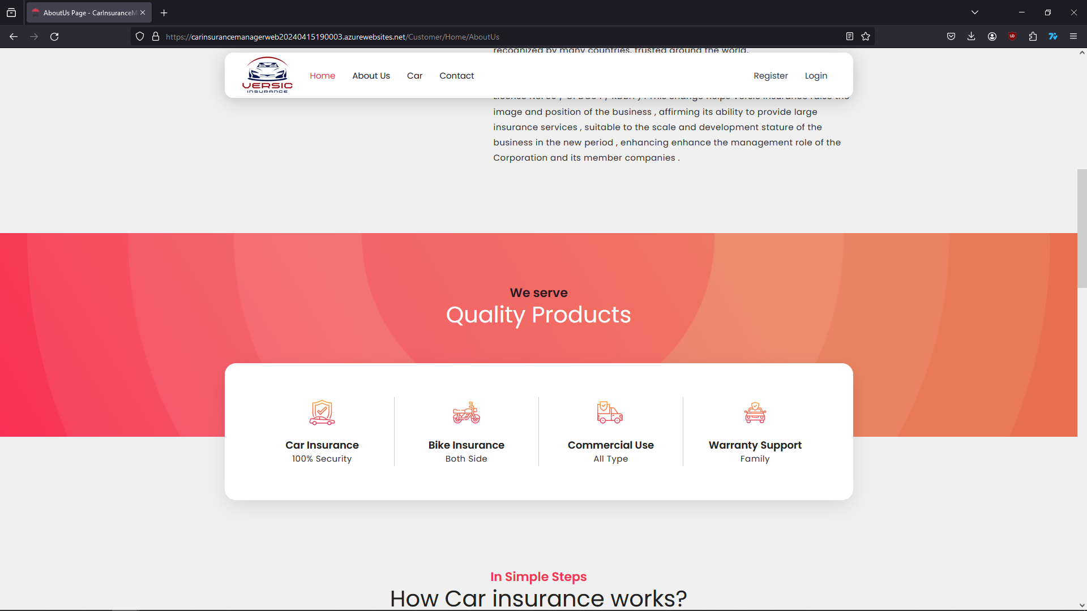

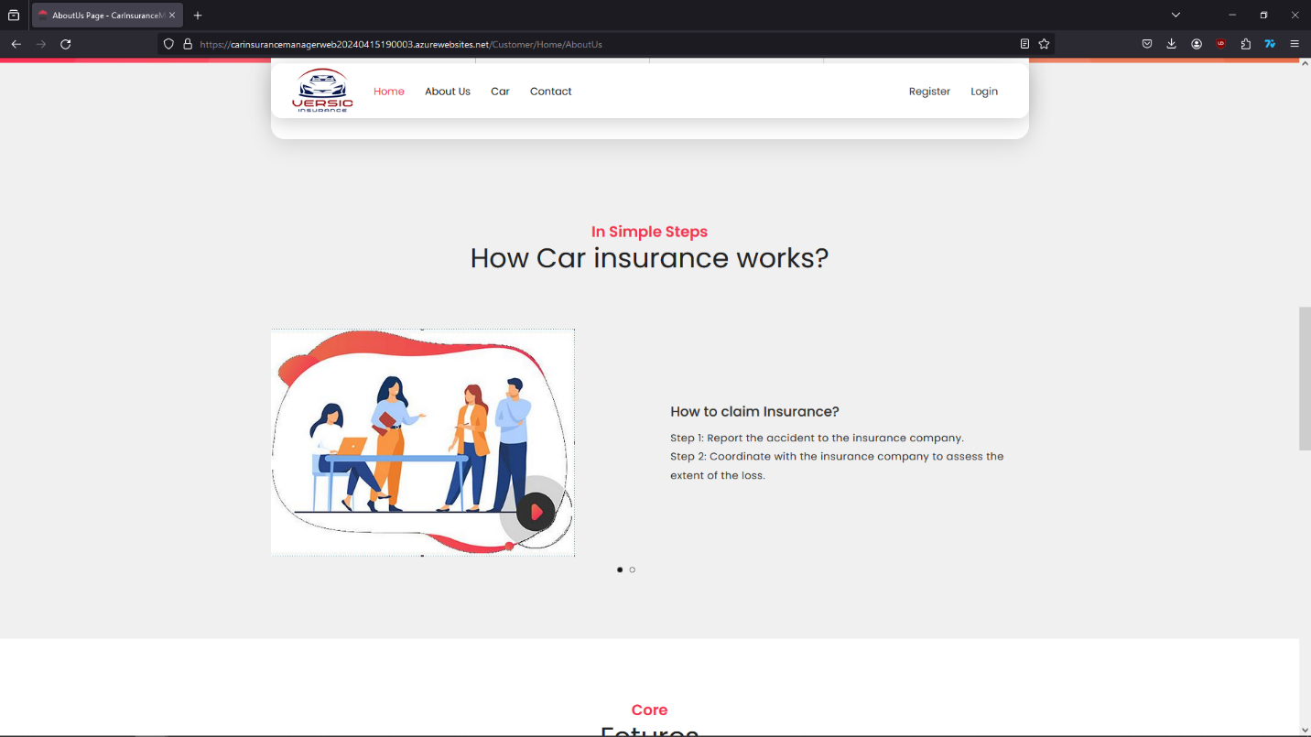

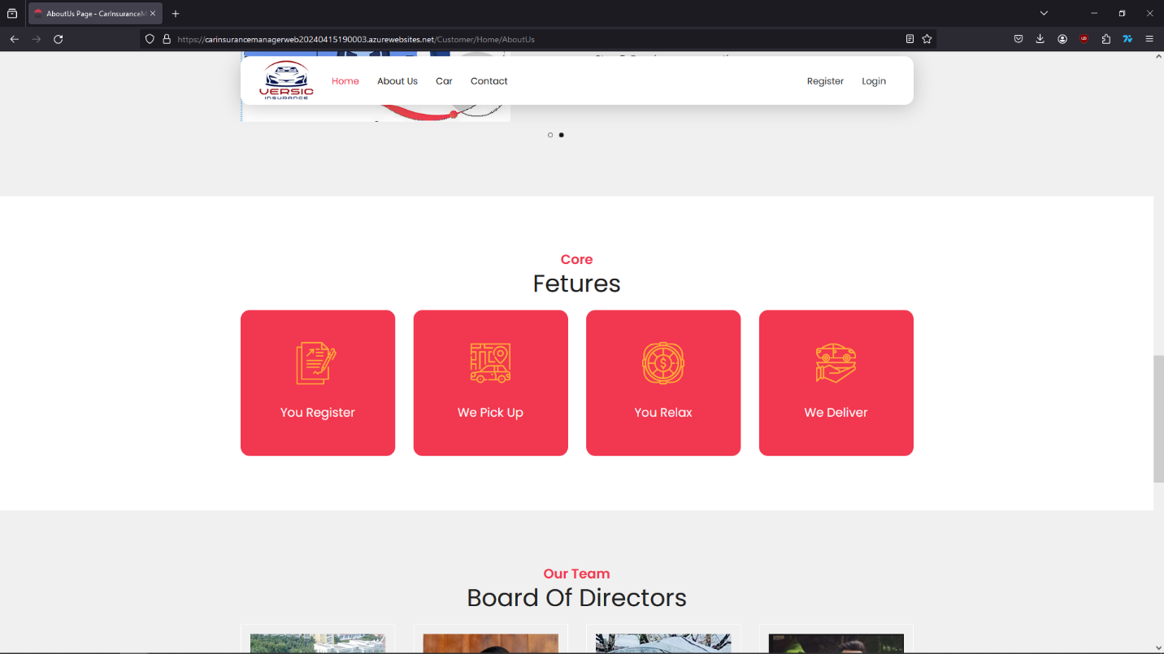

1. Products Site – Types of insurance

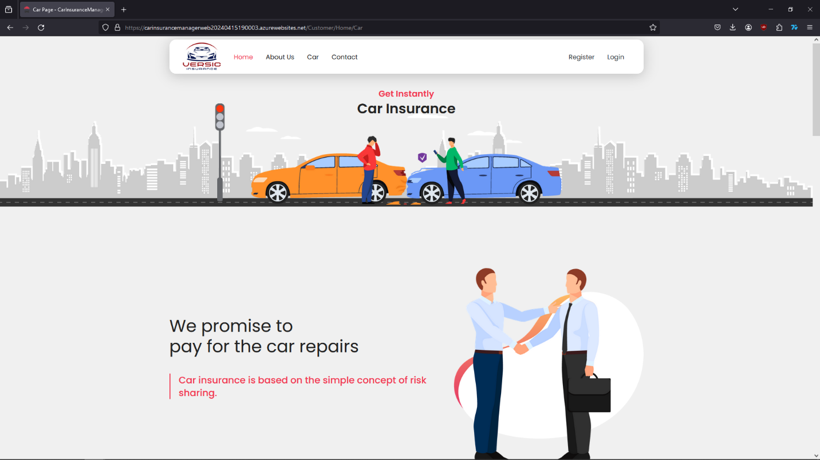

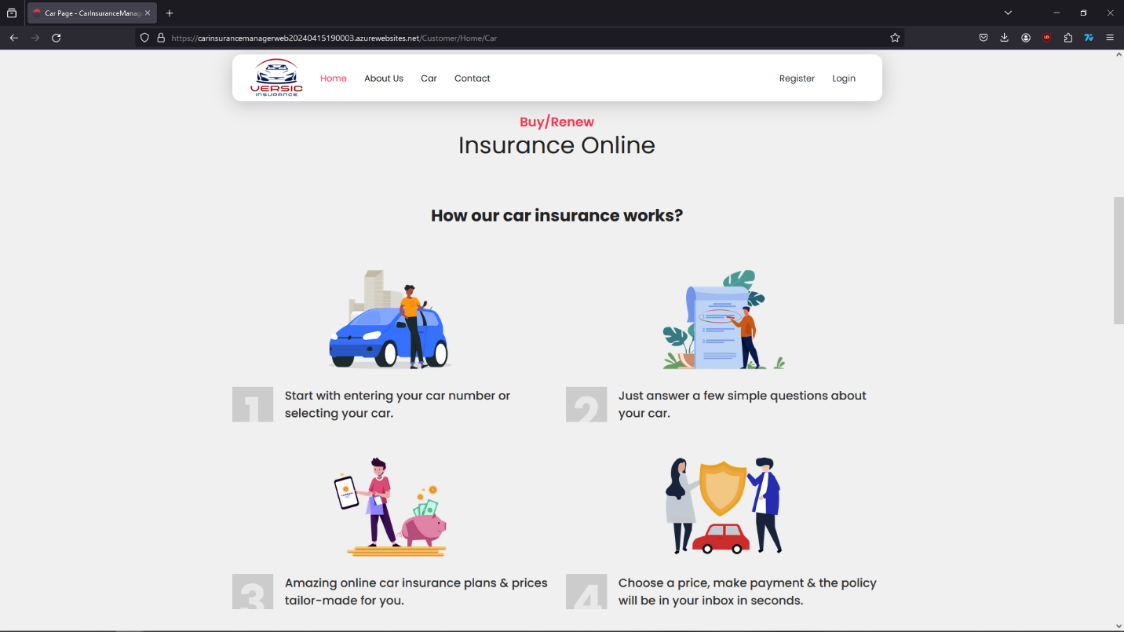

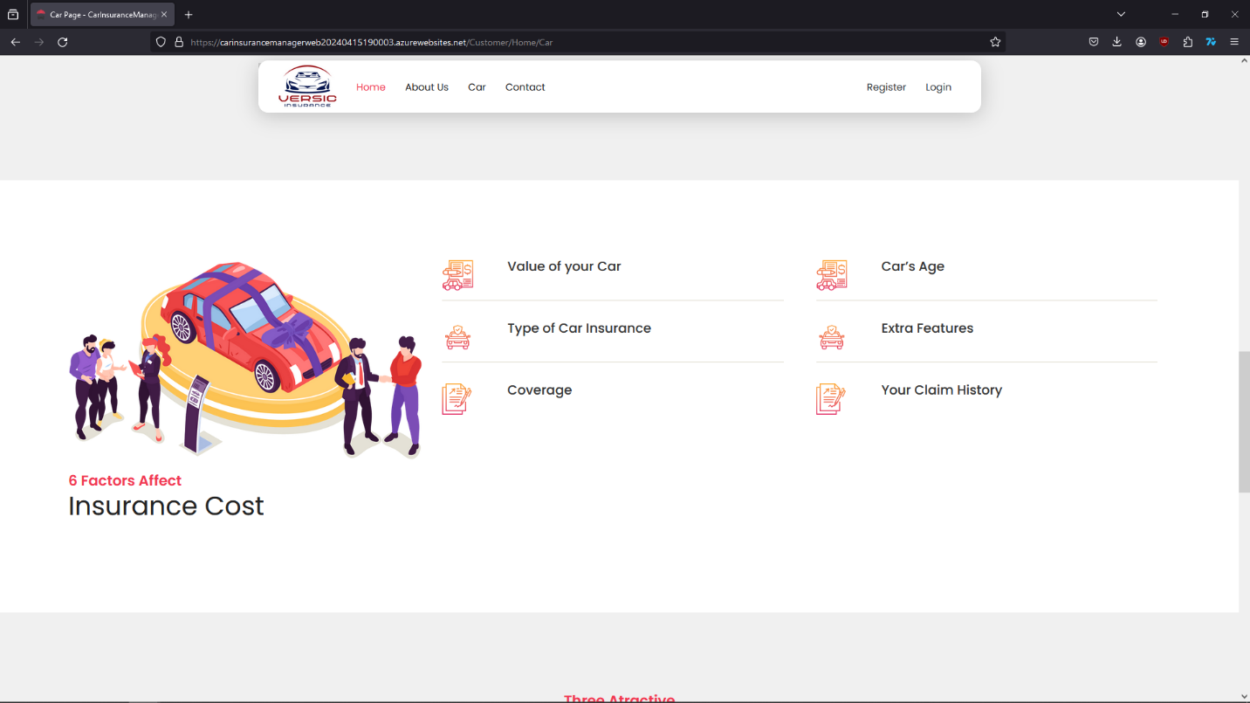

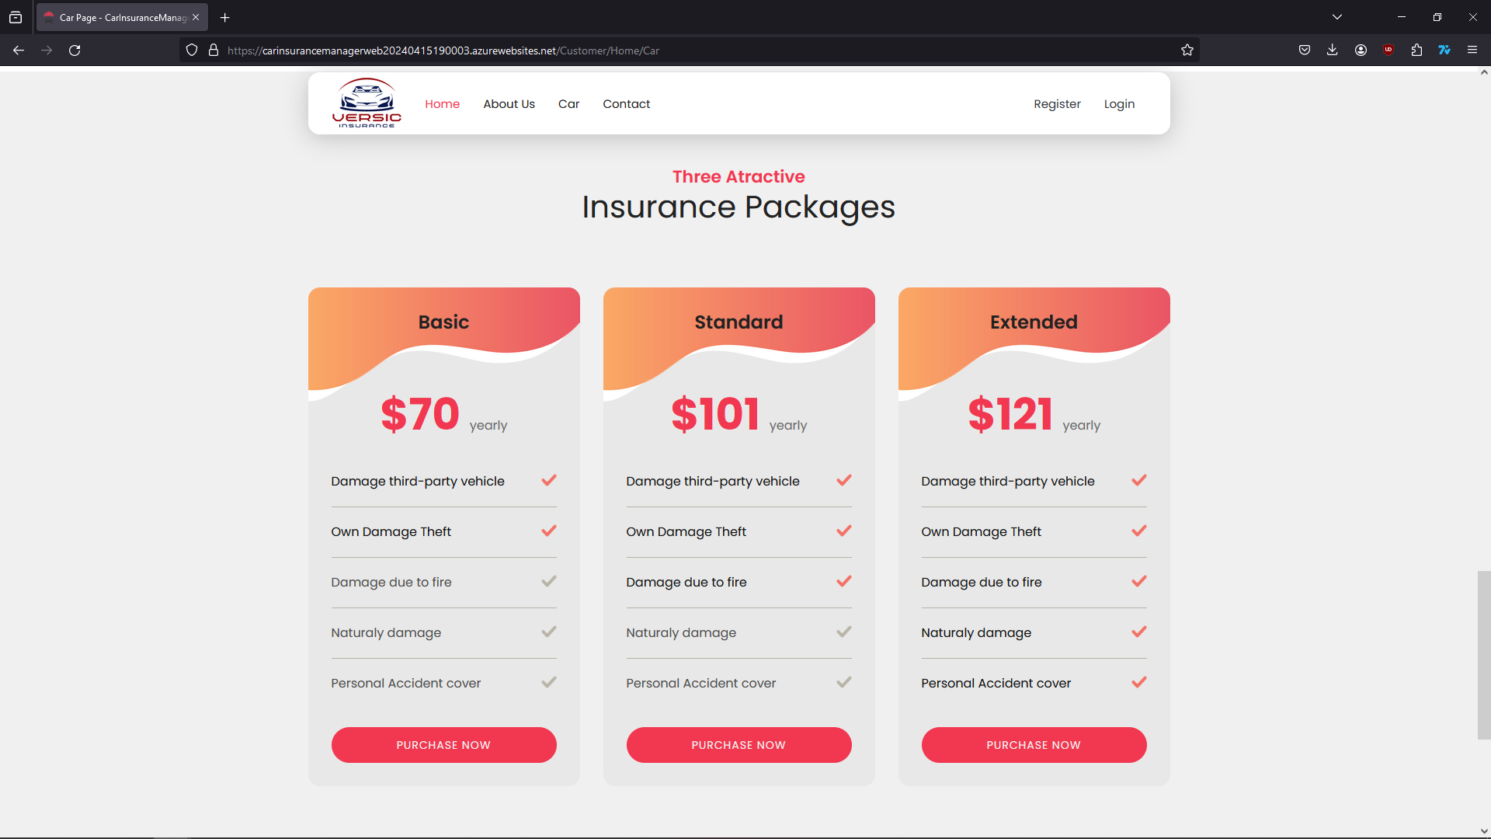

Guests can quickly go to register or log in site by click the “Purchase now” button.

1. Contact Us

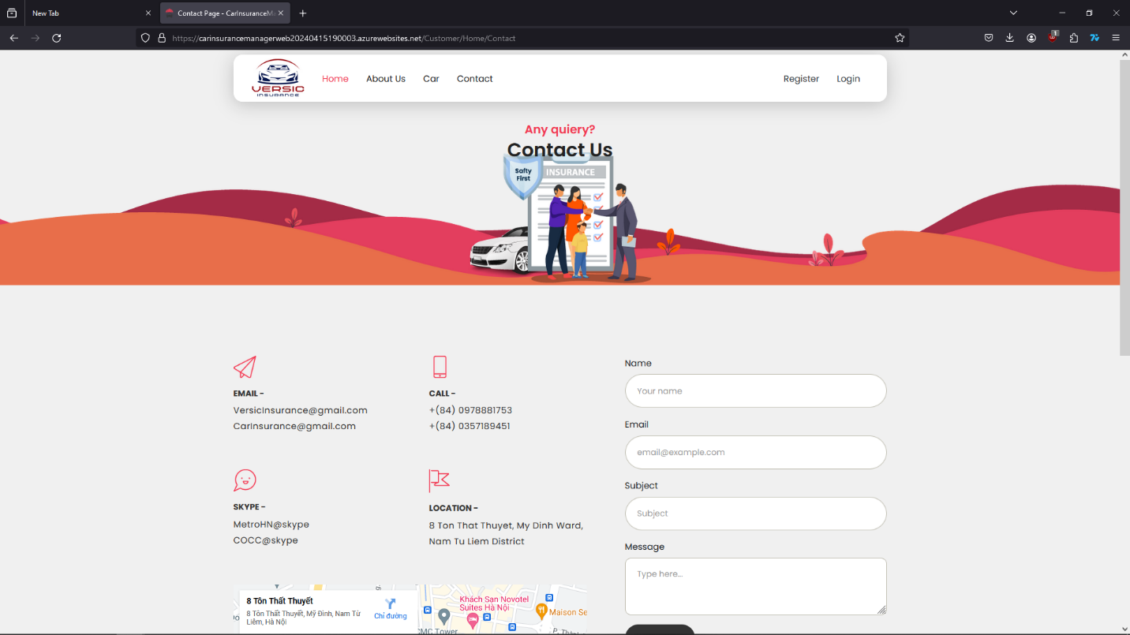

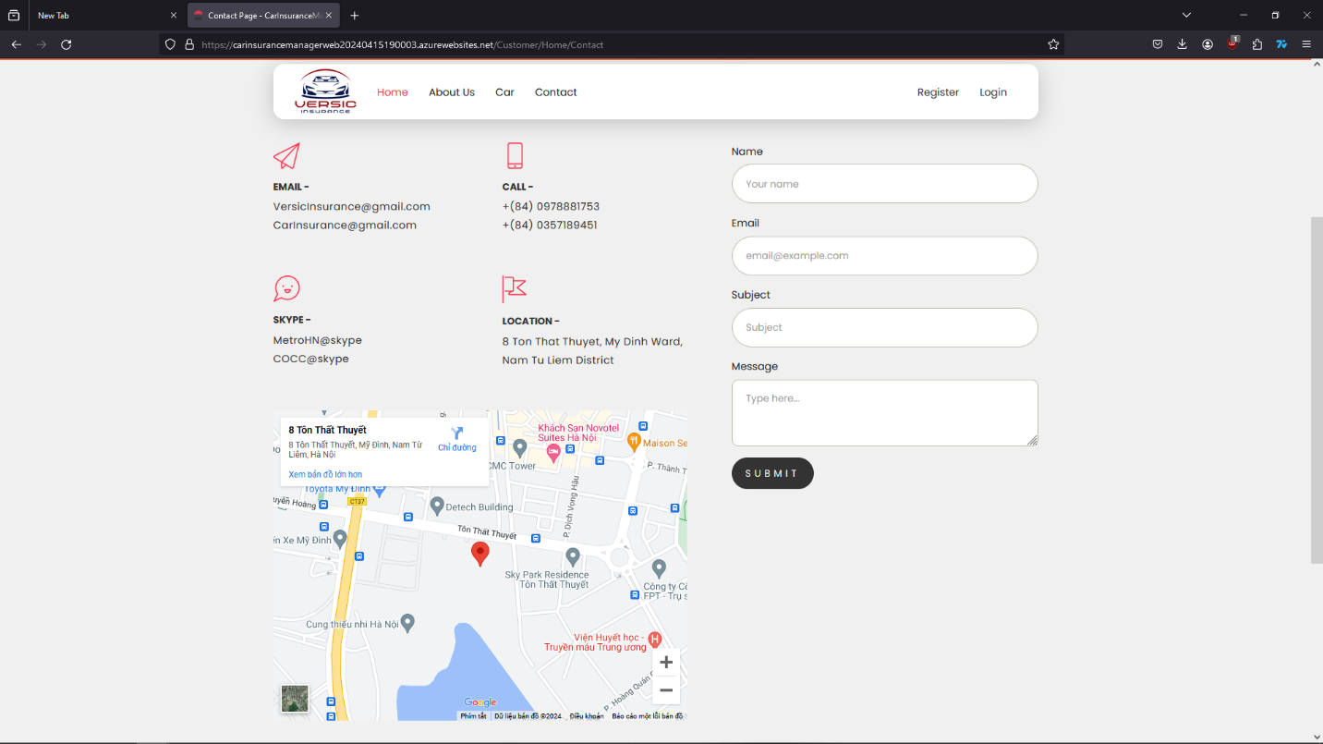

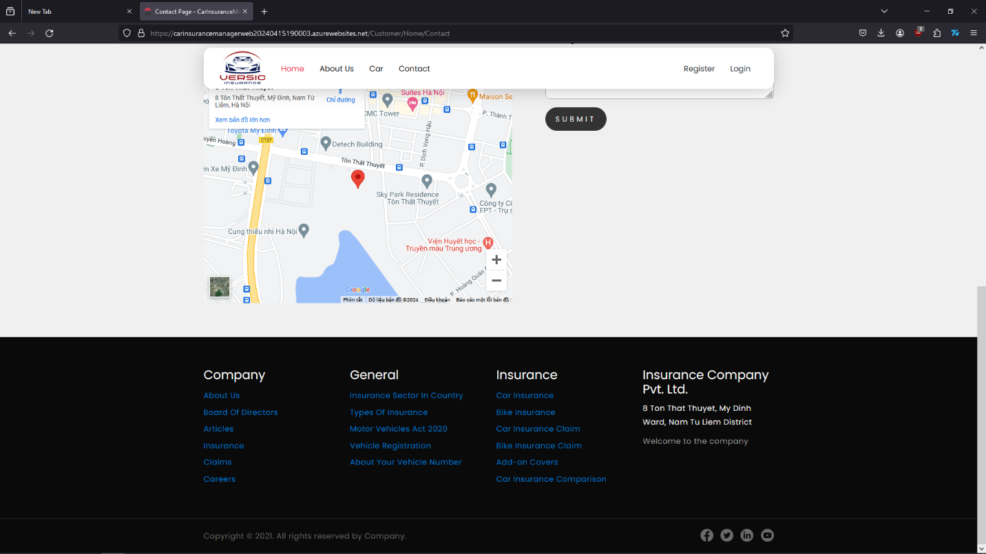

## **CUSTOMER GUIDE**

Guest can click on “Register” button on the navigation bar to make an account and become a customer to start buying products.

1. Register site / Log in site

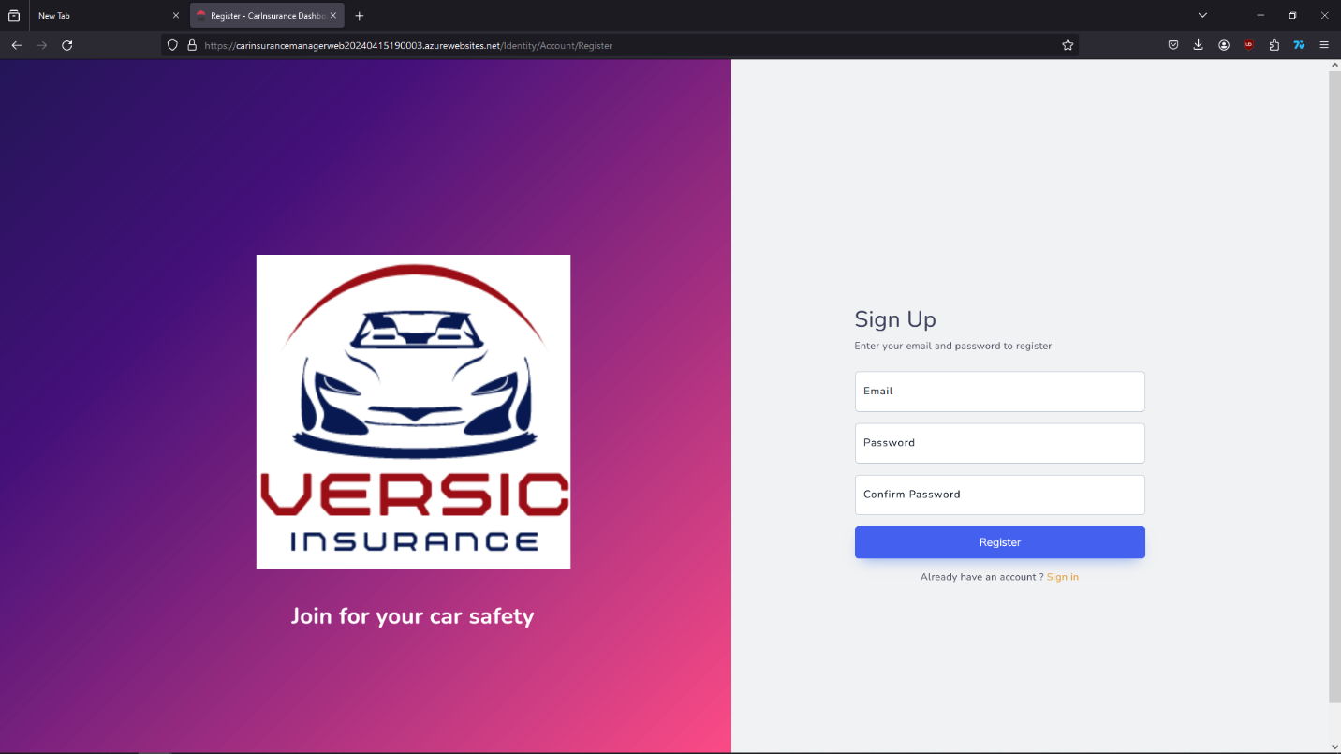

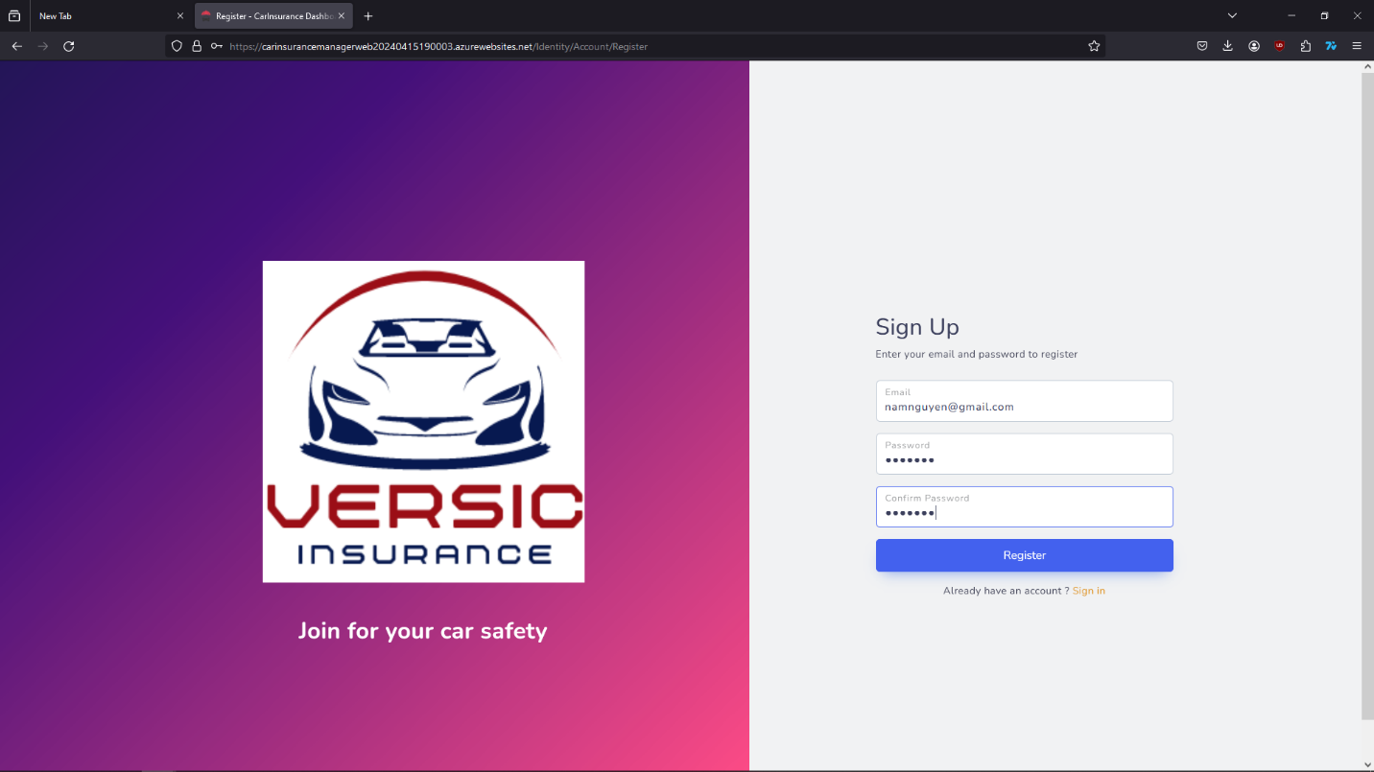

Fill the form with email and create password then press “Register”, very easy, simple and super quick.



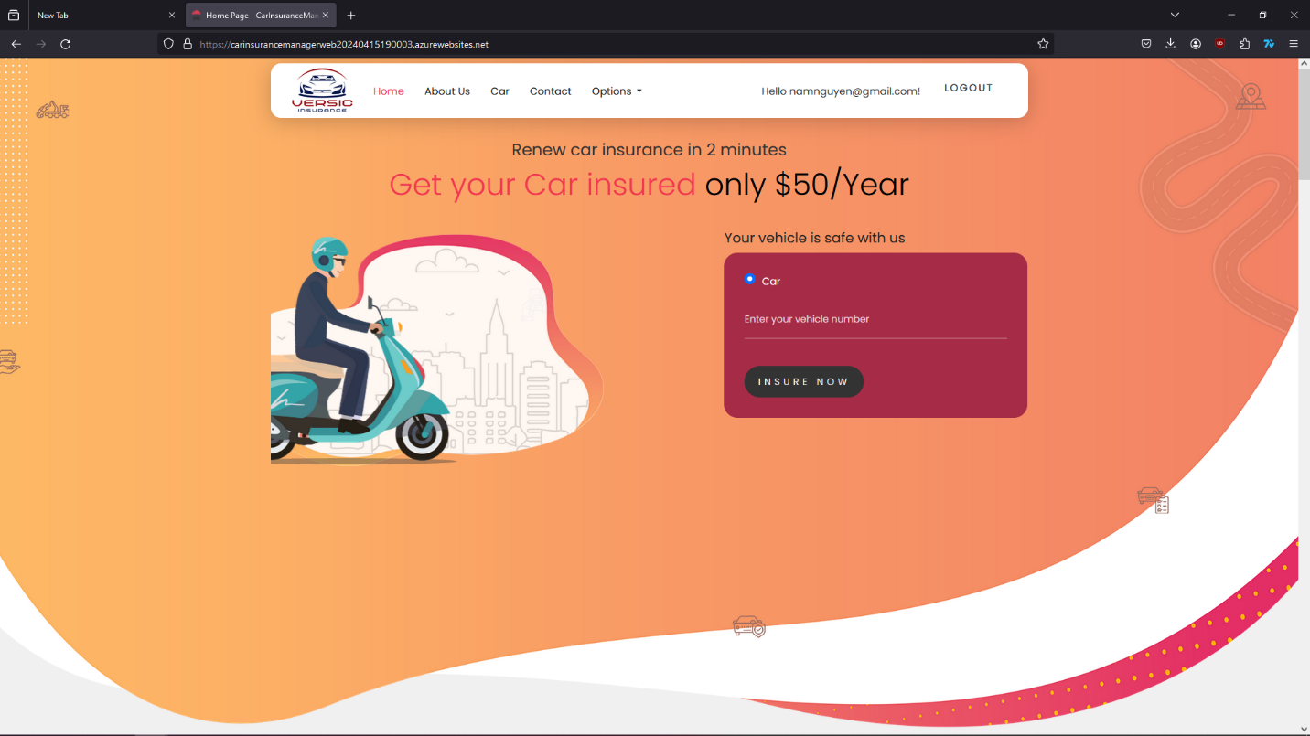

After log in as a customer, they can see the “Option” section on the navigation bar. In the “Option” section customer can buy Insurance, manage their vehicle, calculate the price, manage the record, claim record,…

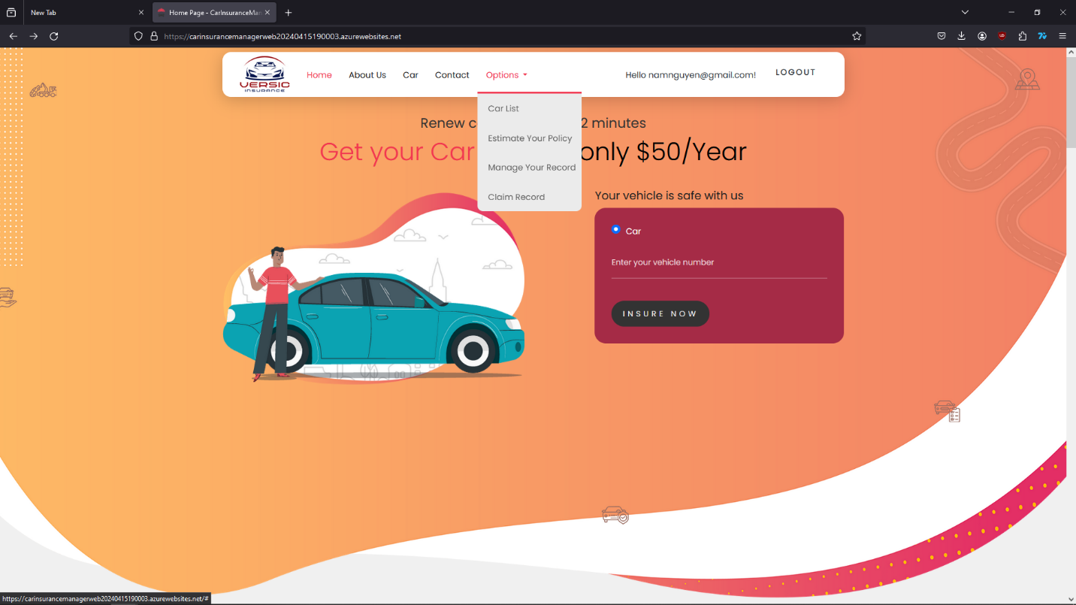

1. Add own vehicle information

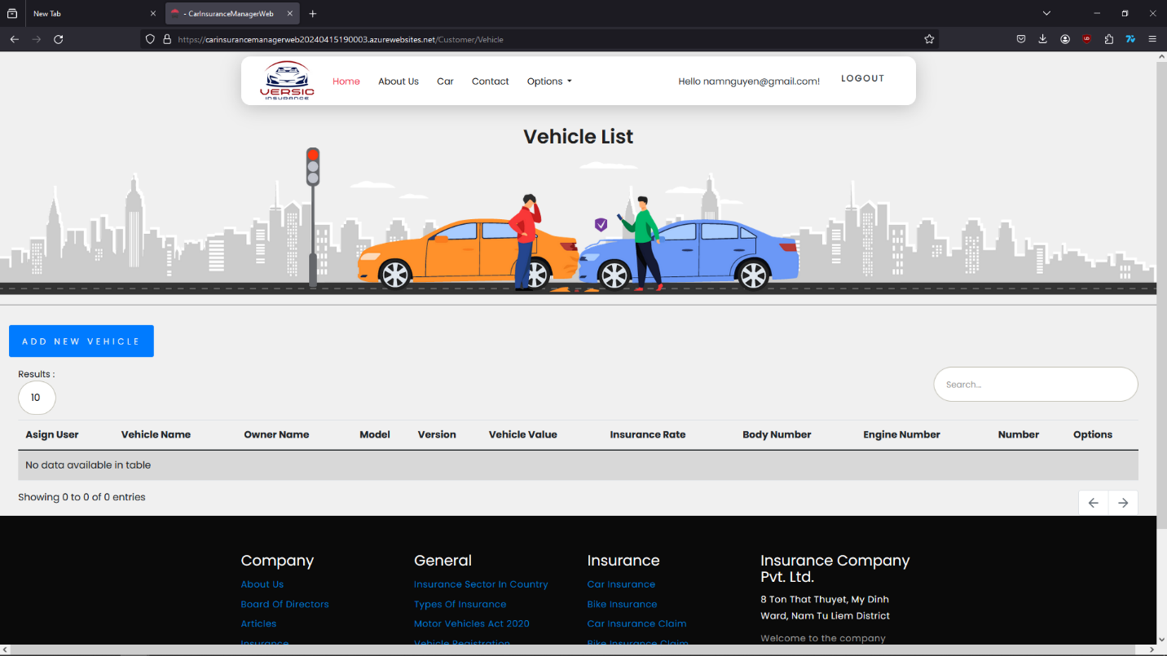

Customer add their own vehicle by press the “ADD NEW VEHICLE” button. Then a form will show up for customer to fill in.

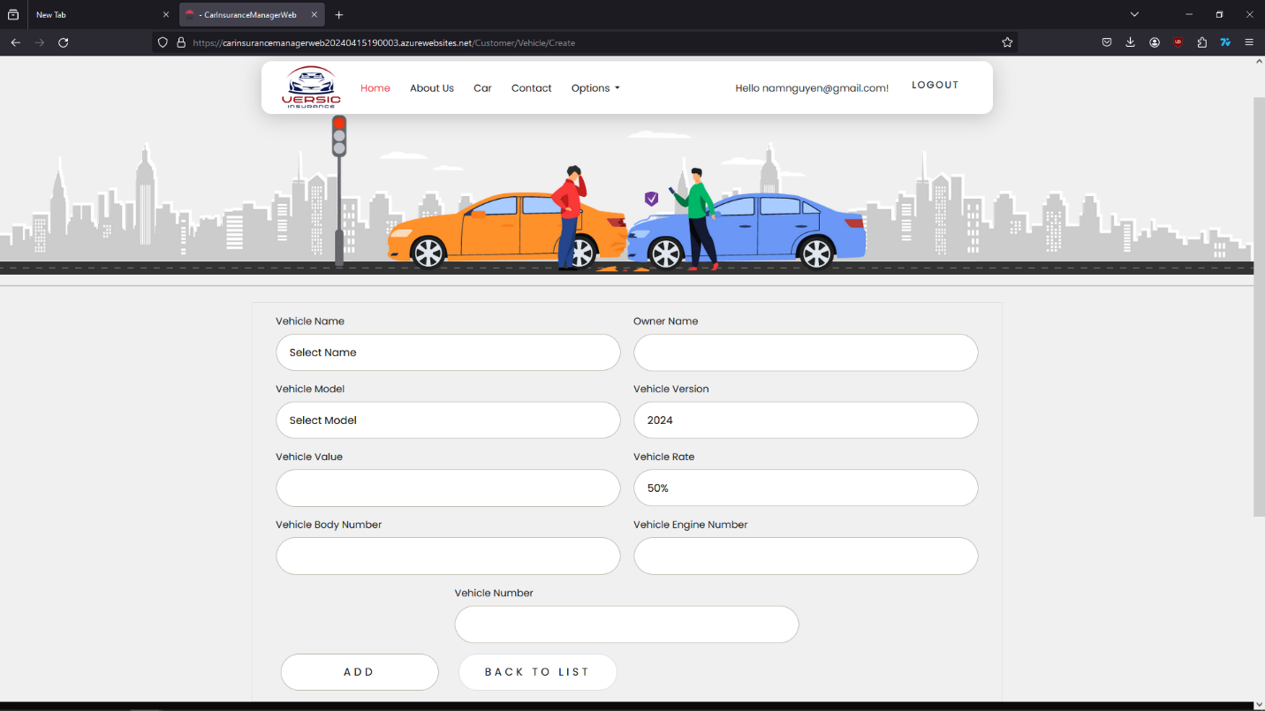

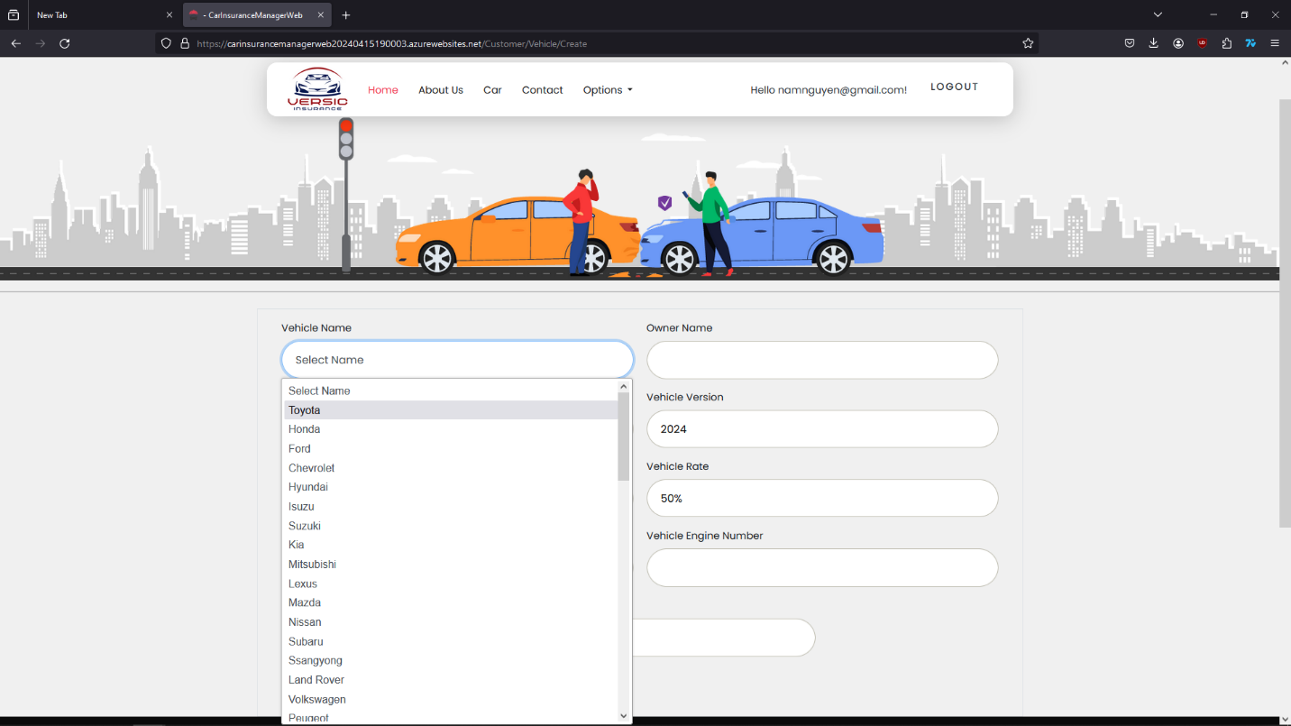

Choose the vehicle brand name, model, vehicle year version, vehicle rate, value of the vehicle, vehicle body number, engine number, owner’s name and license plate.

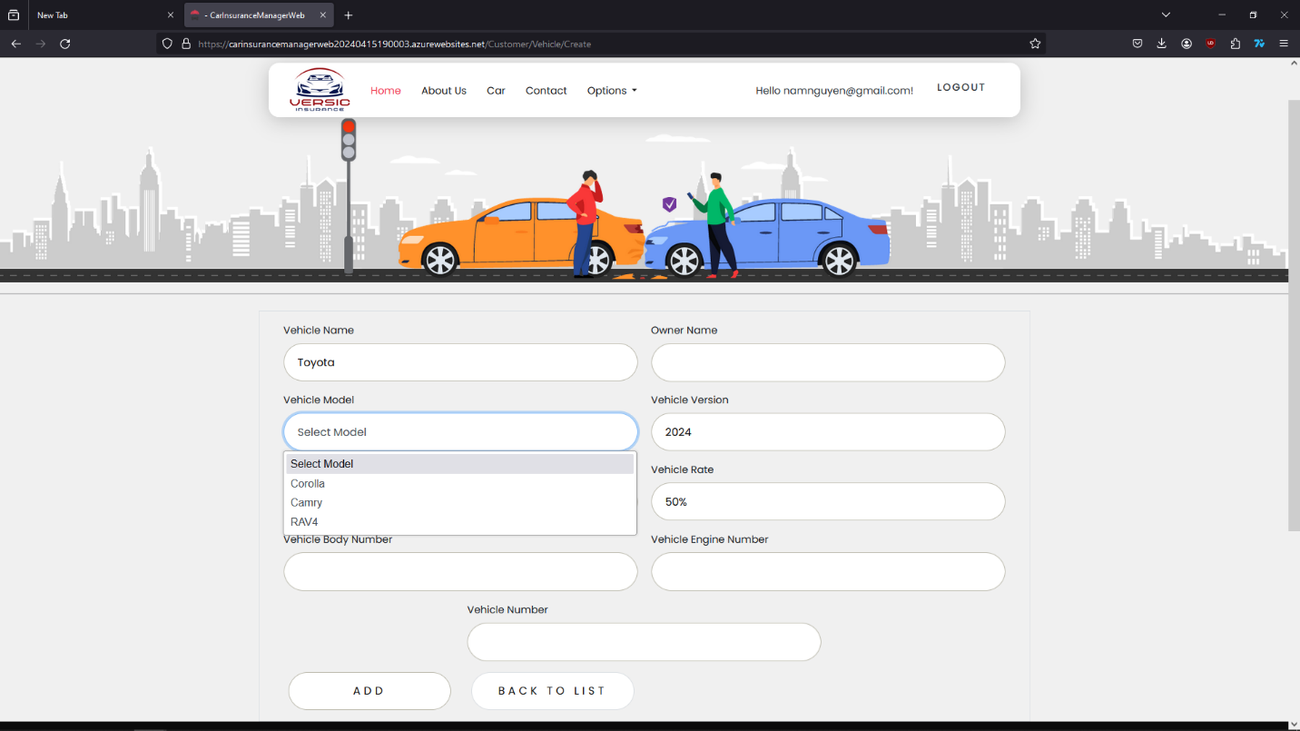

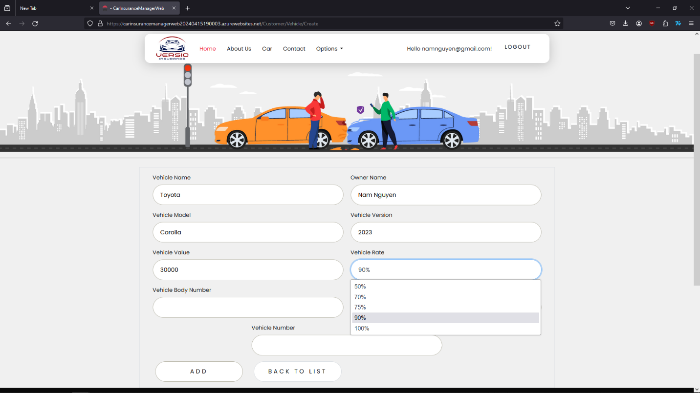

Press the “ADD” button to add the information of the vehicle to the list and start buying Insurance for the vehicle.

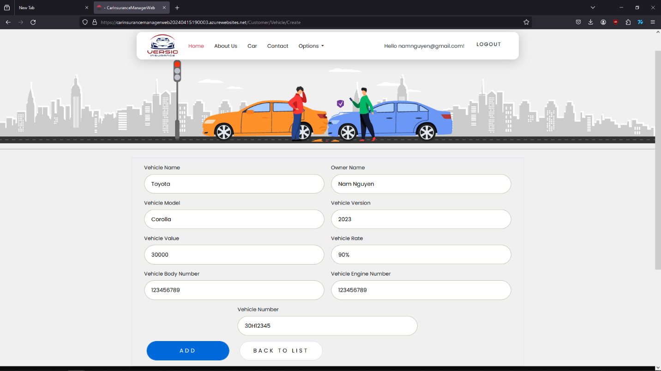

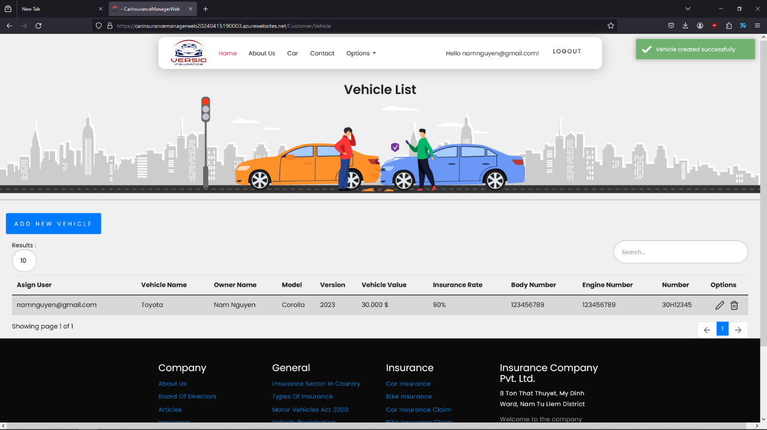

Customer’s vehicle will show on the list. Customer can edit or delete the information. When a customer want to buy Insurance for the vehicle, they can point to “Option” then choose “Estimate Your Policy”.

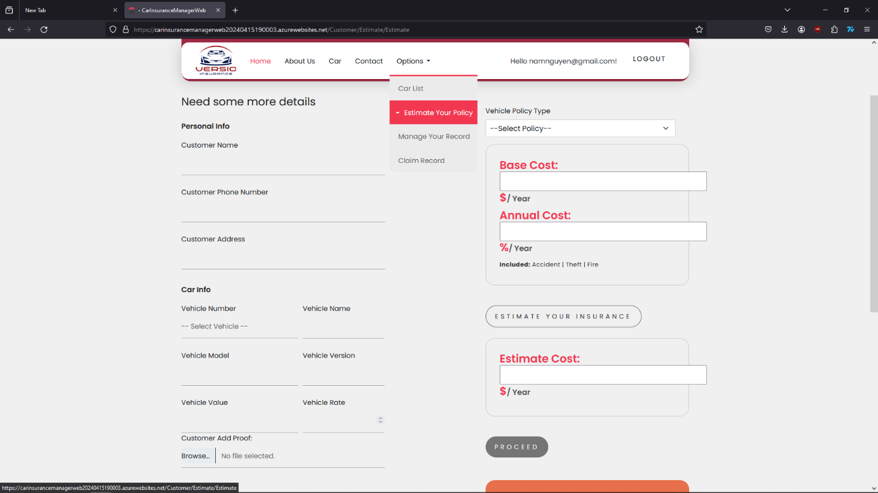

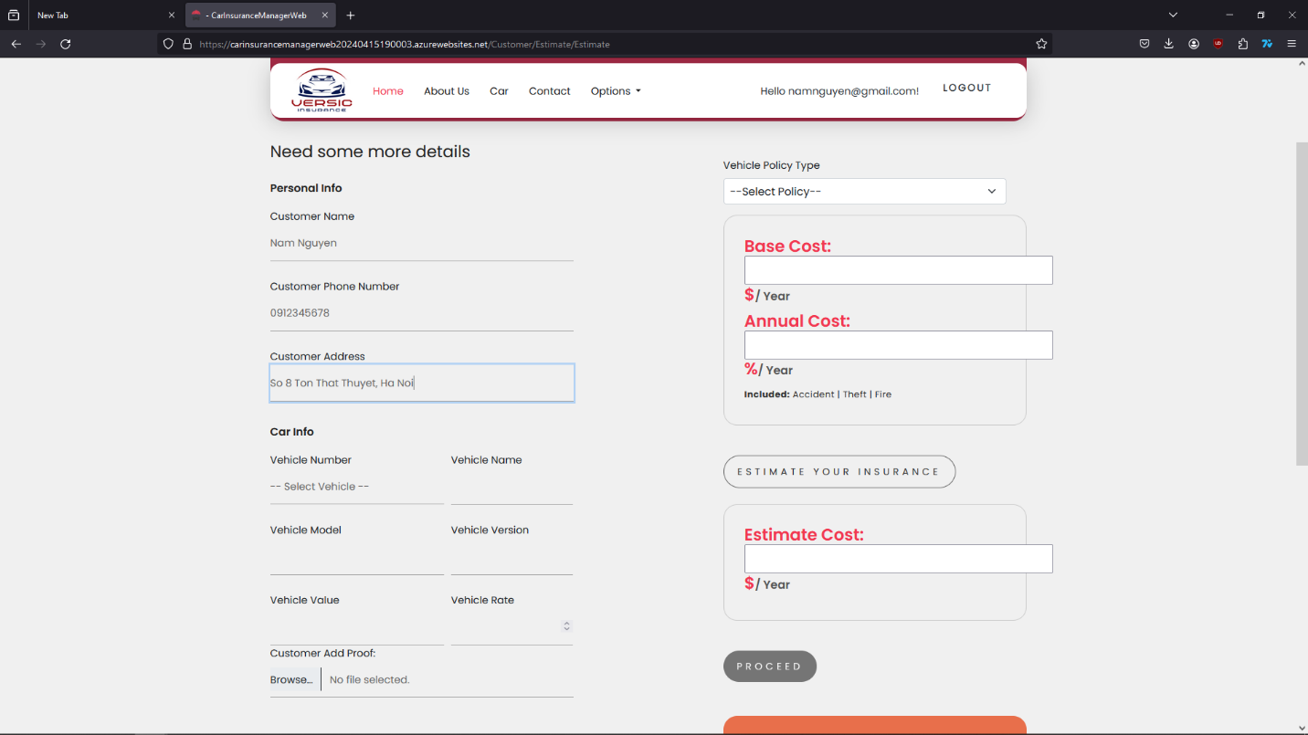

The customer just need to fill in “Personal info”, and choose the vehicle which has been added before.

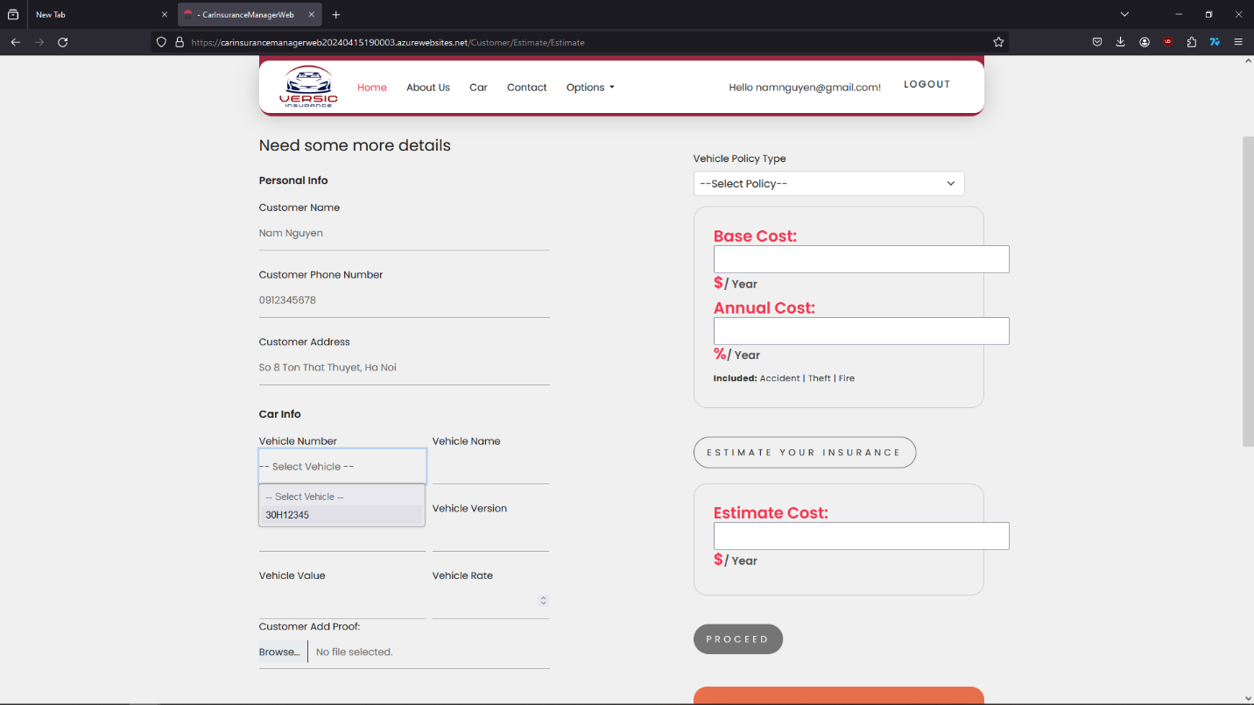

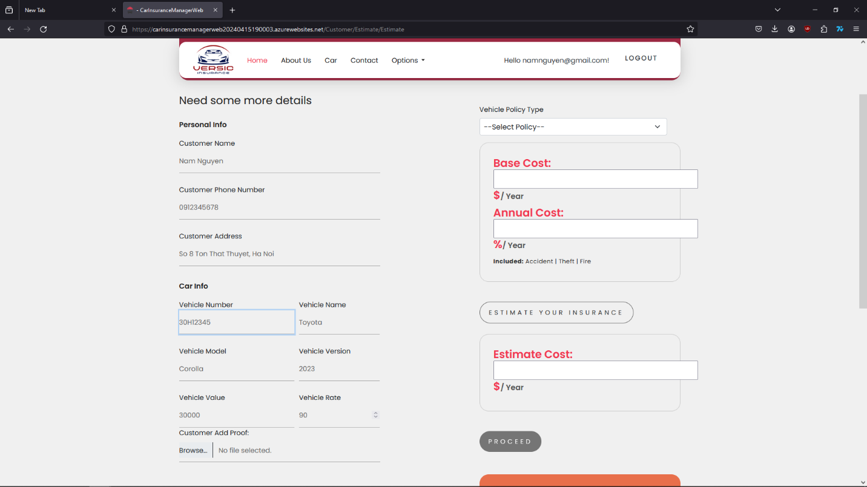

Upload the picture of the vehicle with all the number as the information has been added for checking proof. Then select type of Insurance to start calculating the price.

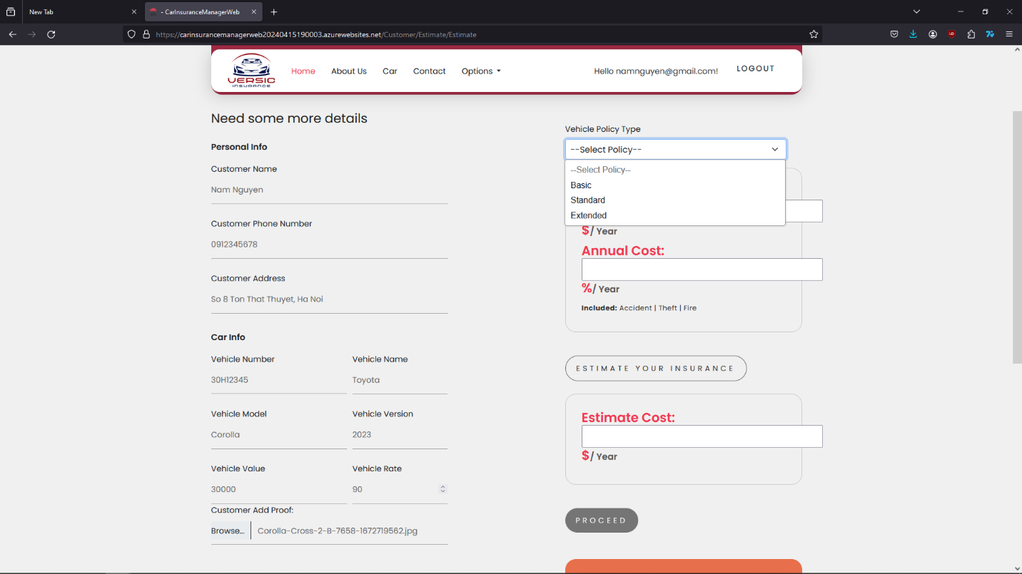

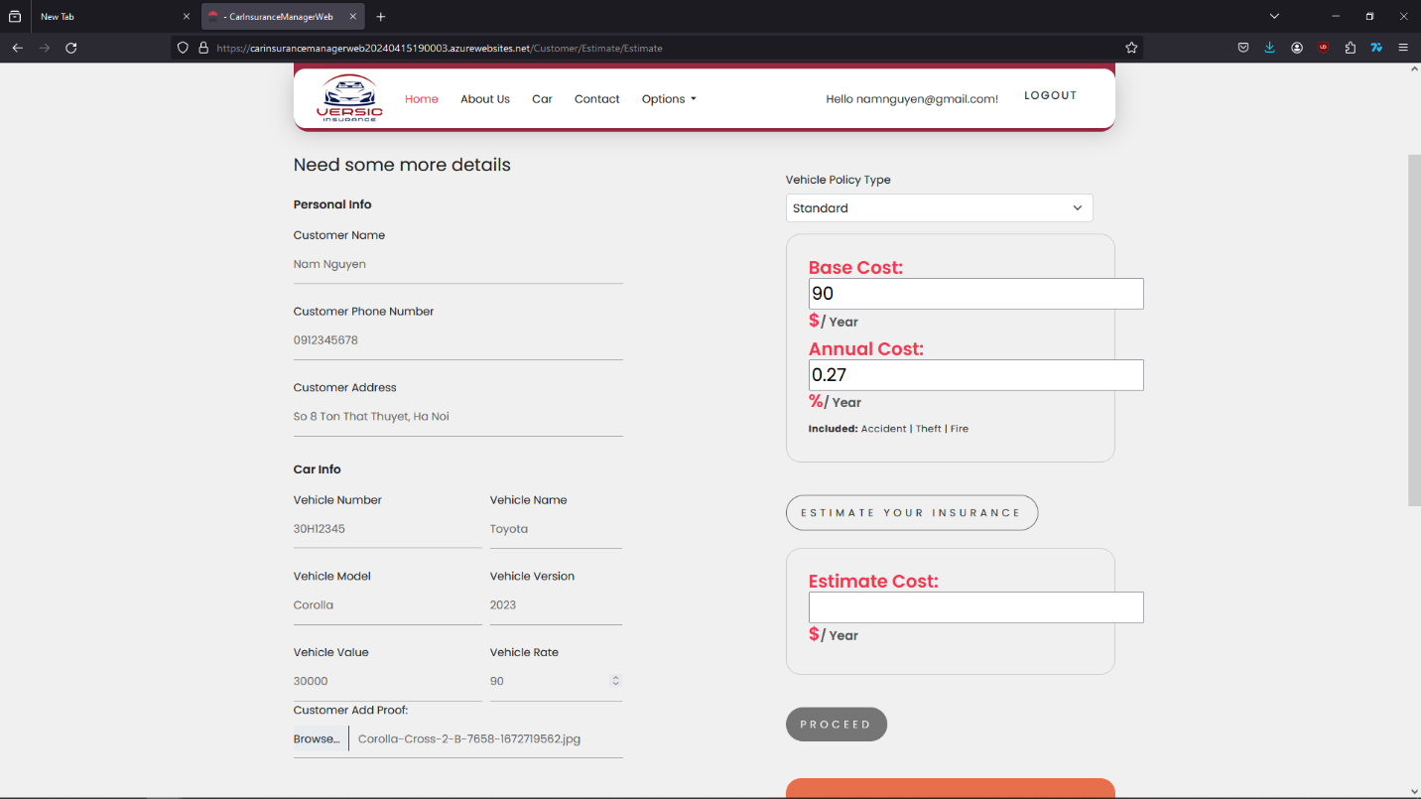

Press on the “Estimate your insurance” button to see the price of your vehicle insurance then click on “Proceed” to send the request.

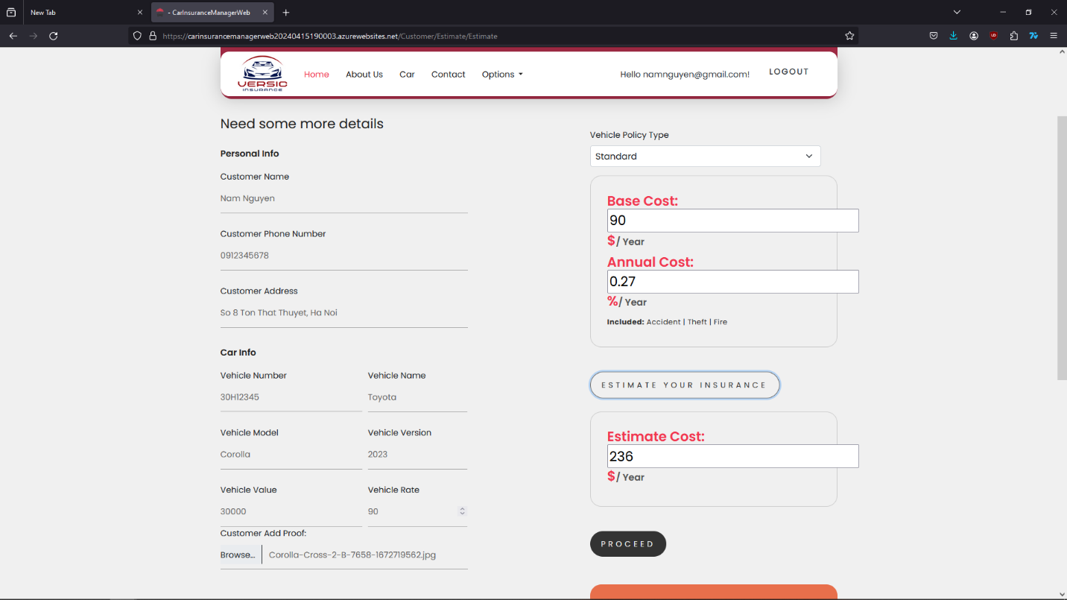

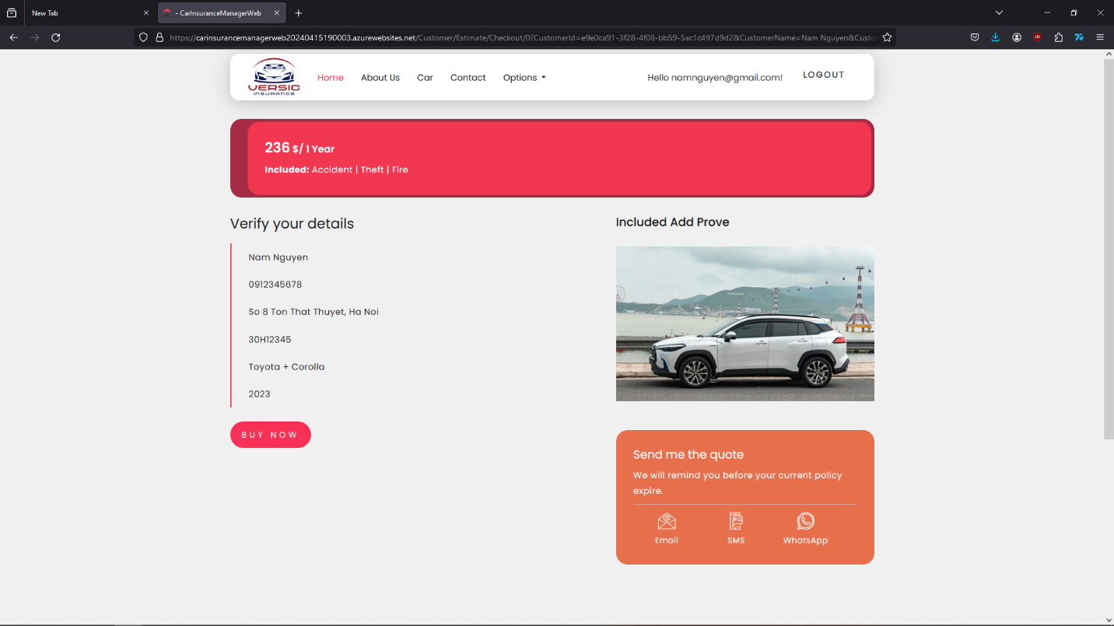

After customer check the information one more time, they can press on “Buy Now” if they decide to buy the Insurance. Request will be sent to the admin to checking and change status of the Insurance.

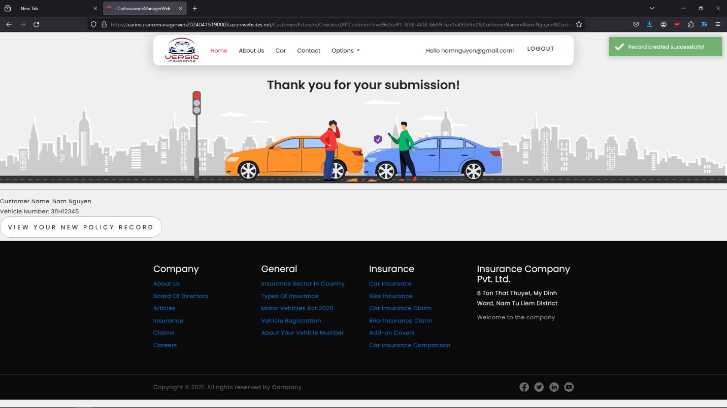

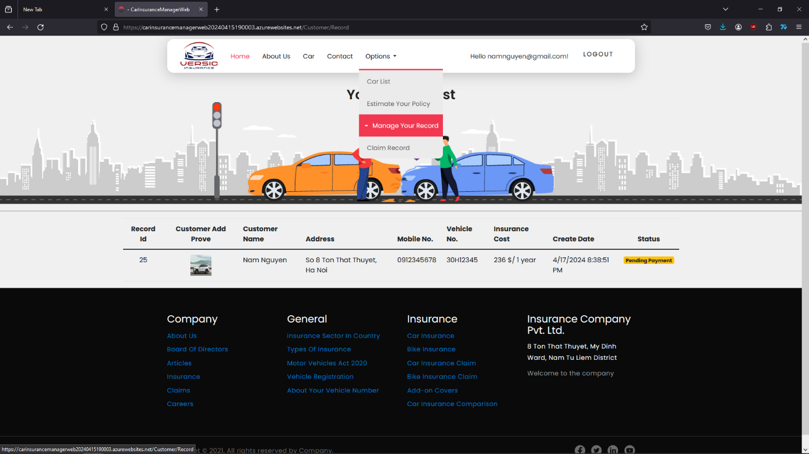

The customer can check the status of their policy in “Manage your Insurance”. If there is an accident happened to the **insured vehicle** and they need to get a Claim Fee, they can go to the section “Claim Record” to make a request.

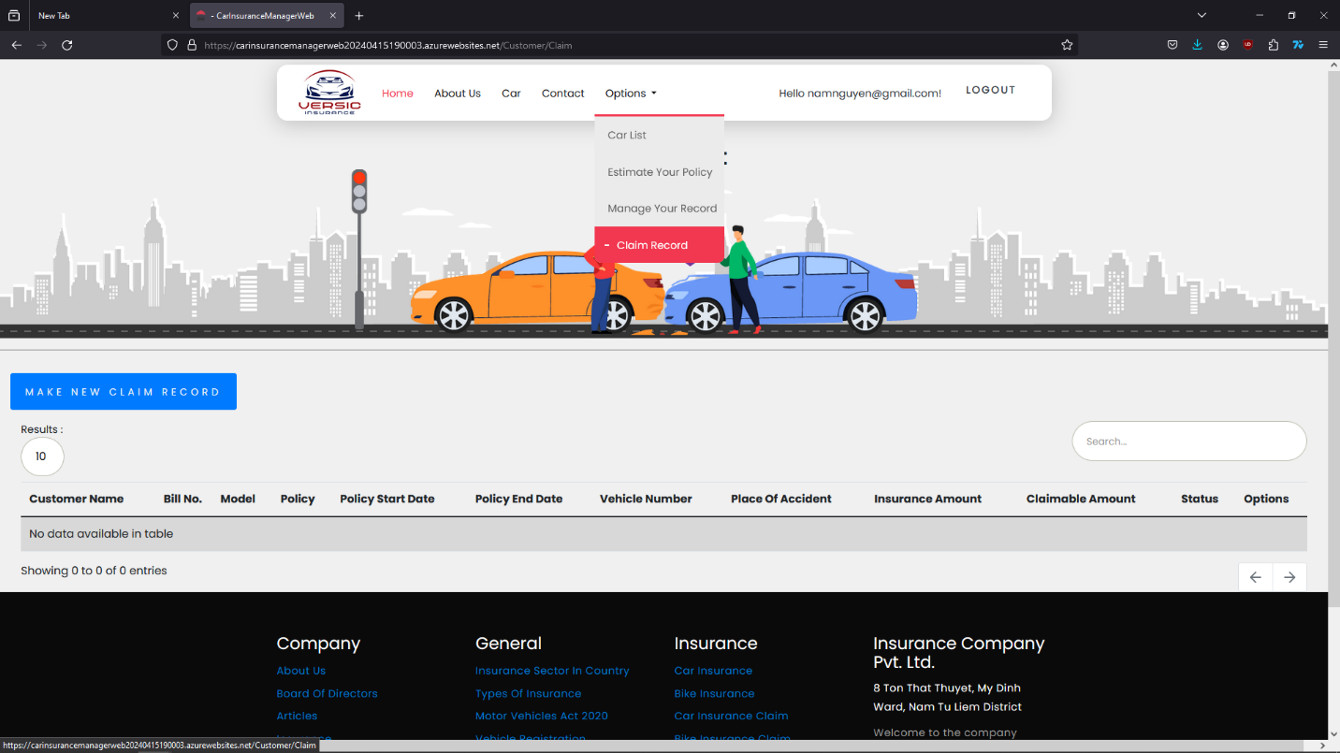

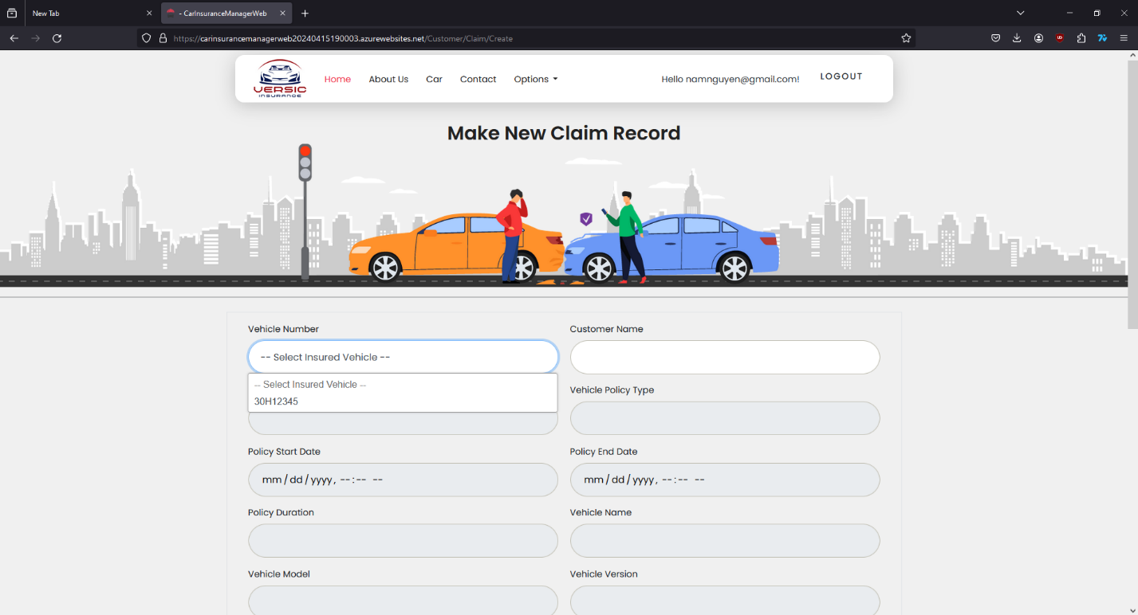

Customer simply choose the insured vehicle on the list and all the information of the vehicle will be automatically fill the form.

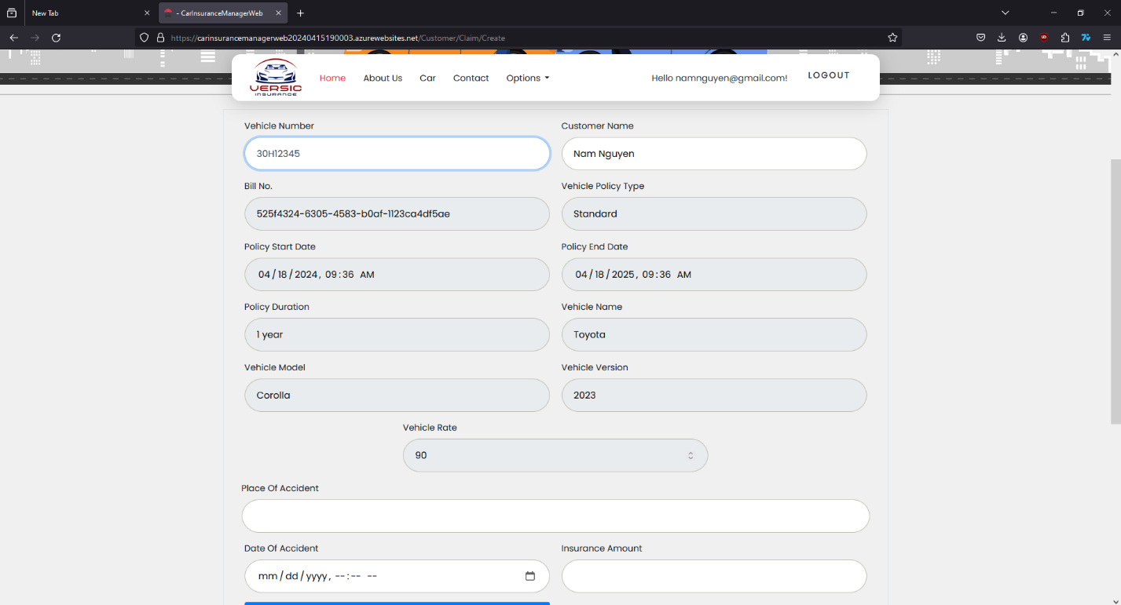

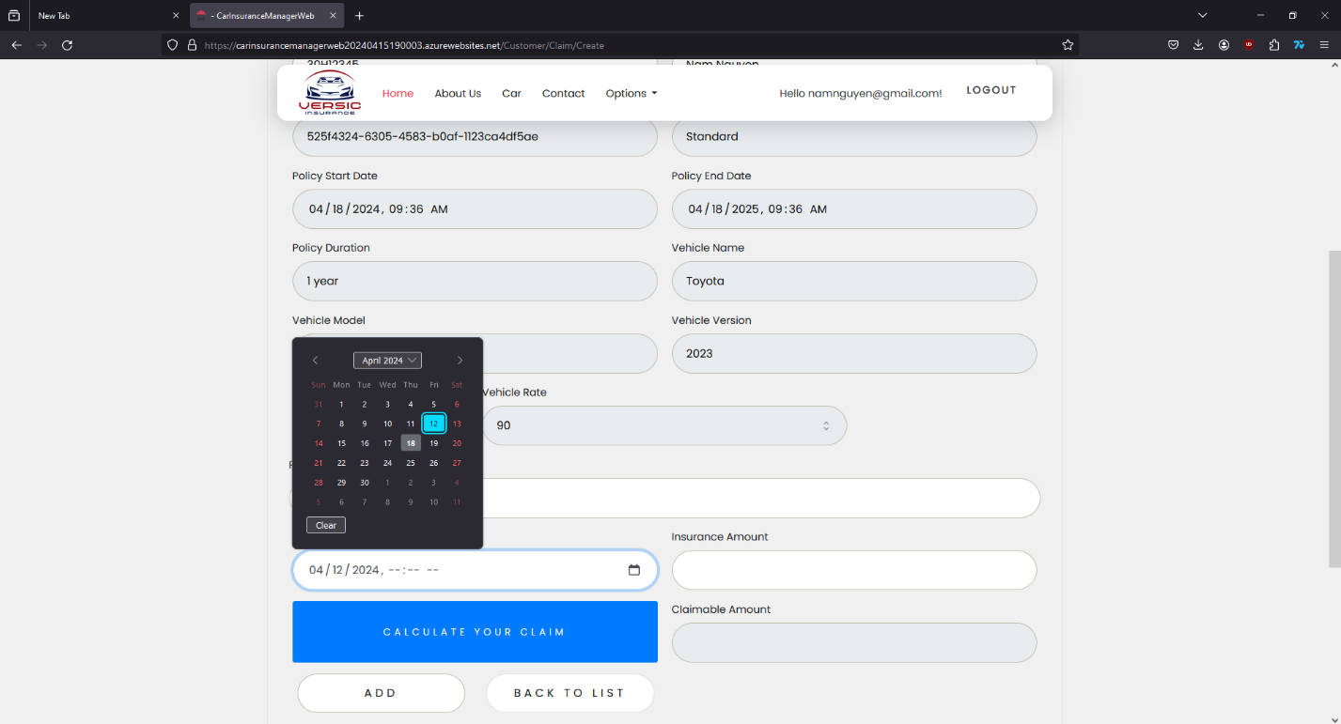

Customer just need to give the details about time and place when accident happened and the cost of repairing.

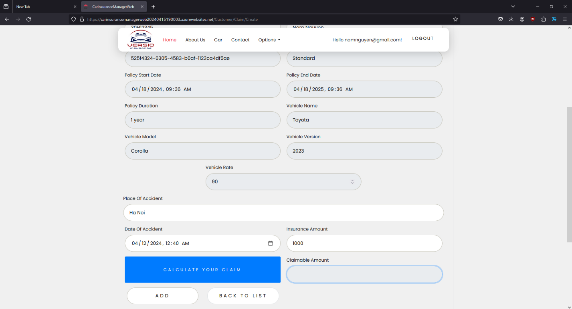

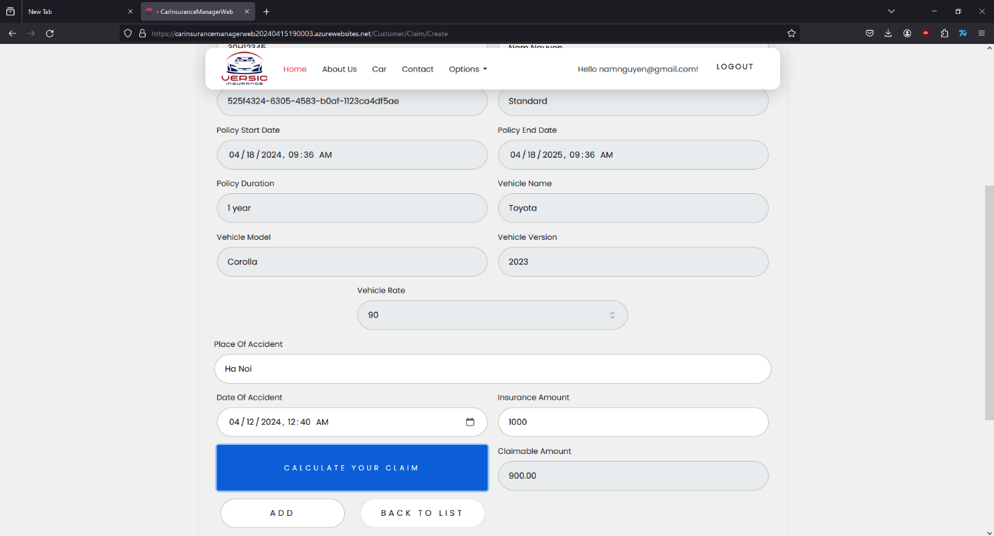

Press on “Calculate your claim” to see the amount of money pay back. Then press on “ADD” to add the request for Admin to check. Status of the request will show in “Claim Record” under “Option” section. Customer can edit or delete the request if they need to.

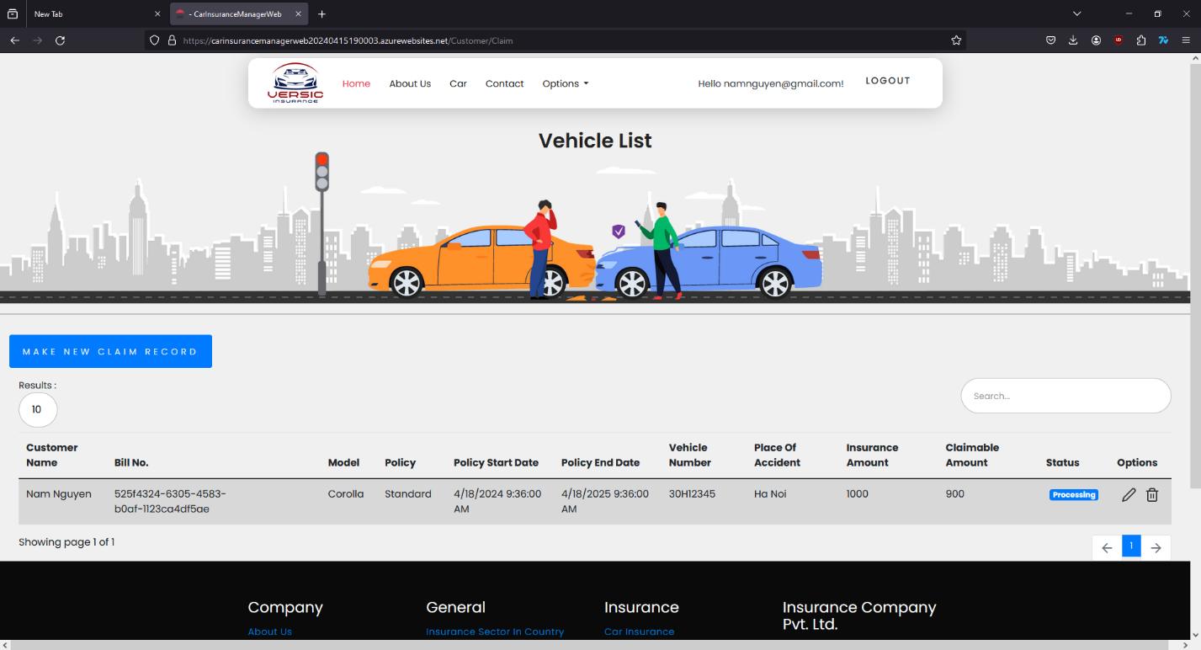

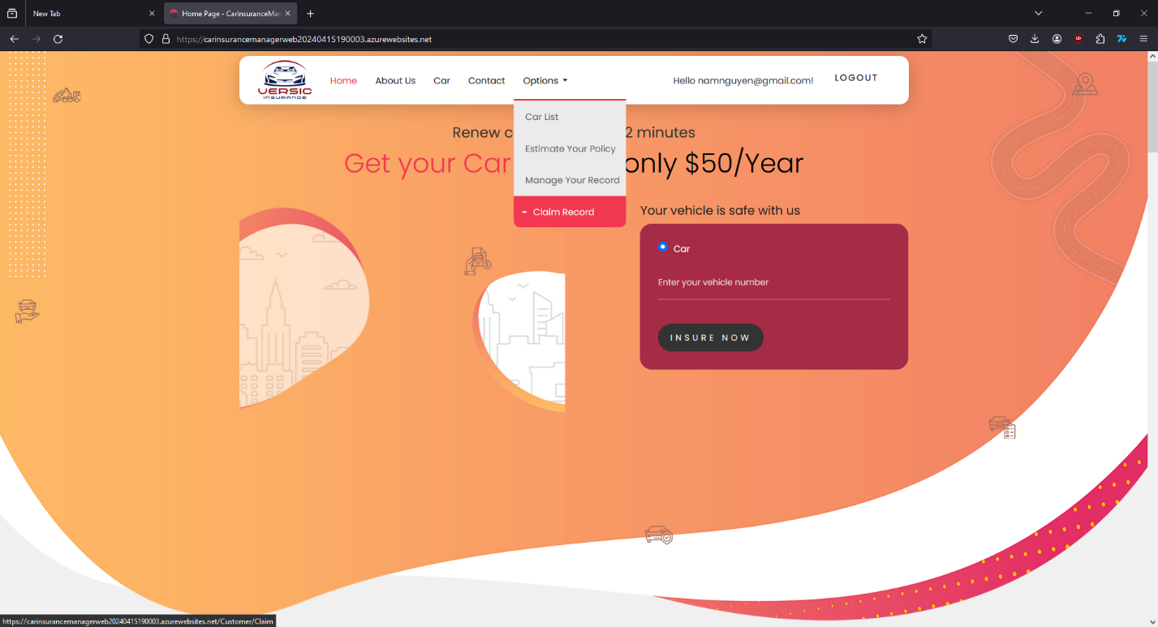

After Admin done with working on customer claim request, they can find the status of request in tab “Claim Record” if it’s done or has been canceled.

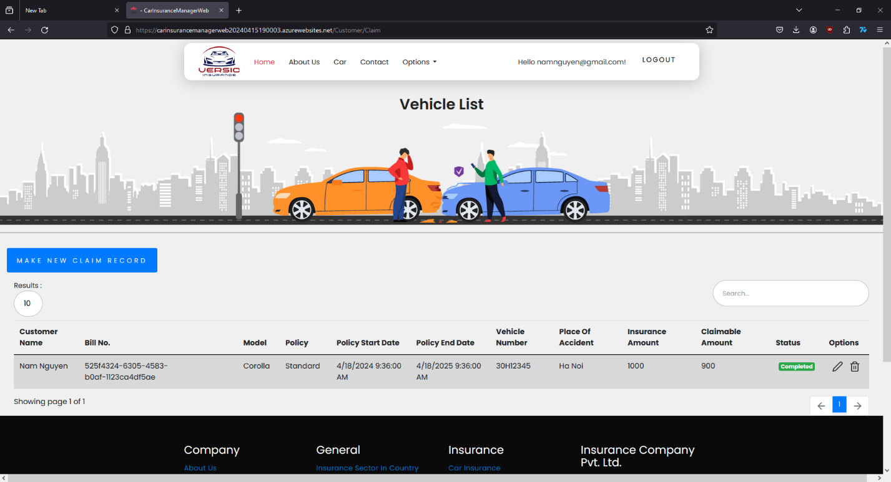

## **ADMIN GUIDE**

* Employee will be admin who can login with admin user name and password.
* He can perform all the admin functions as maintaining the policy records, claim records, payment schedules etc
* Following reports needs to be generated
  + Monthly sell of policies
  + Vehicle wise analysis
  + Claims report
  + Policies due renewals
  + Policies lapsed report

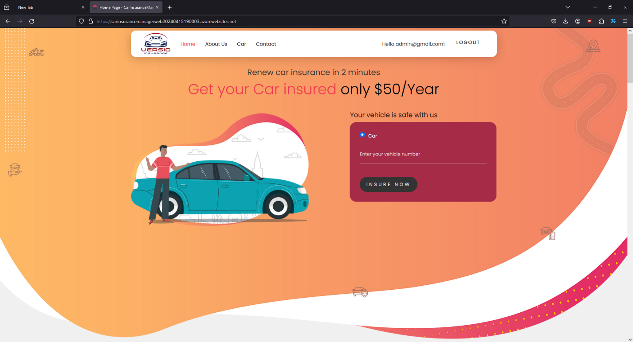

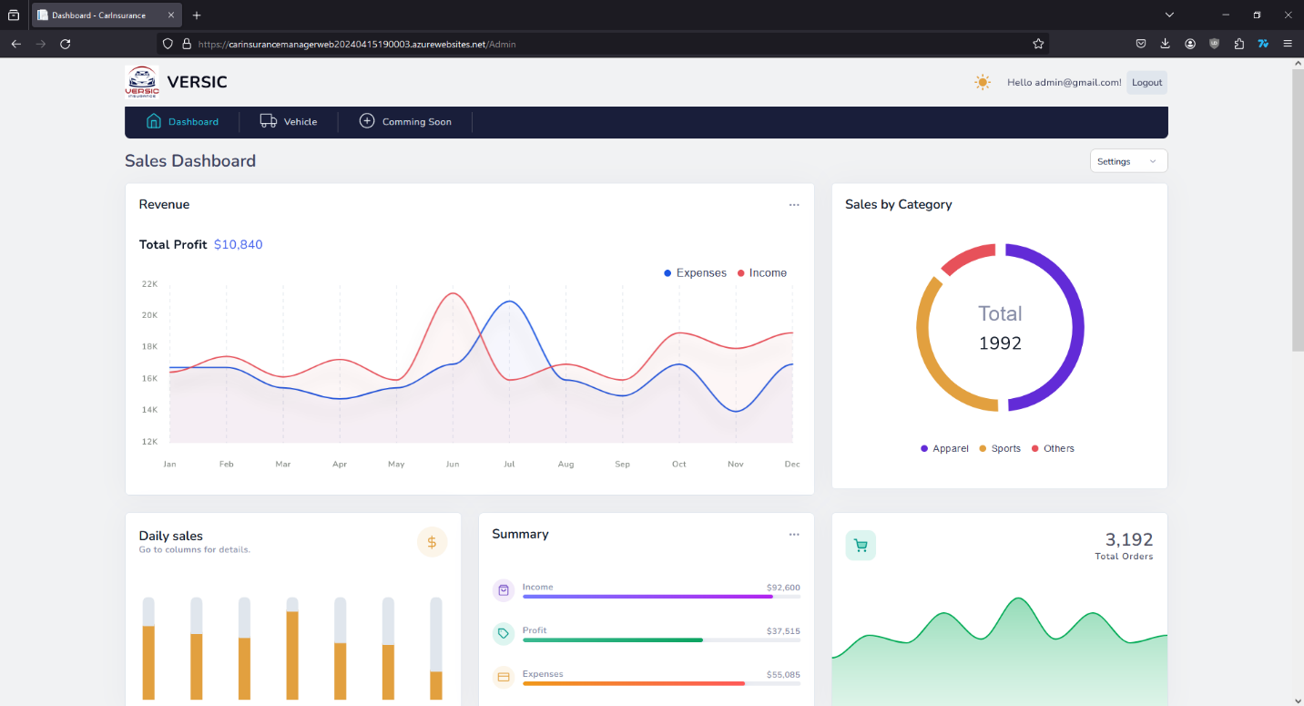

Admin has a different interface with Dashboard and charts with detail numbers.

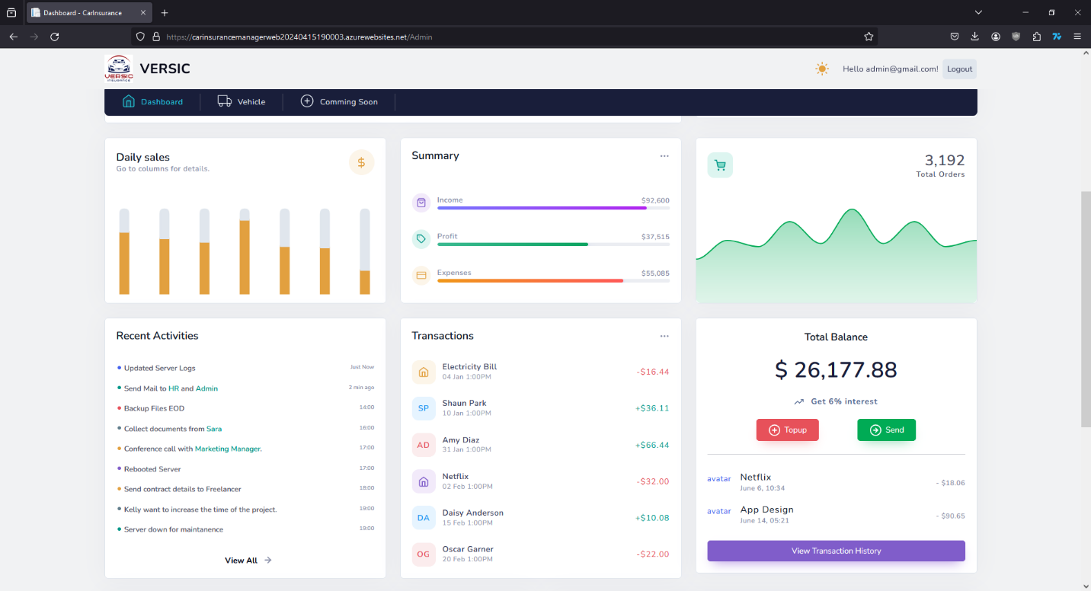

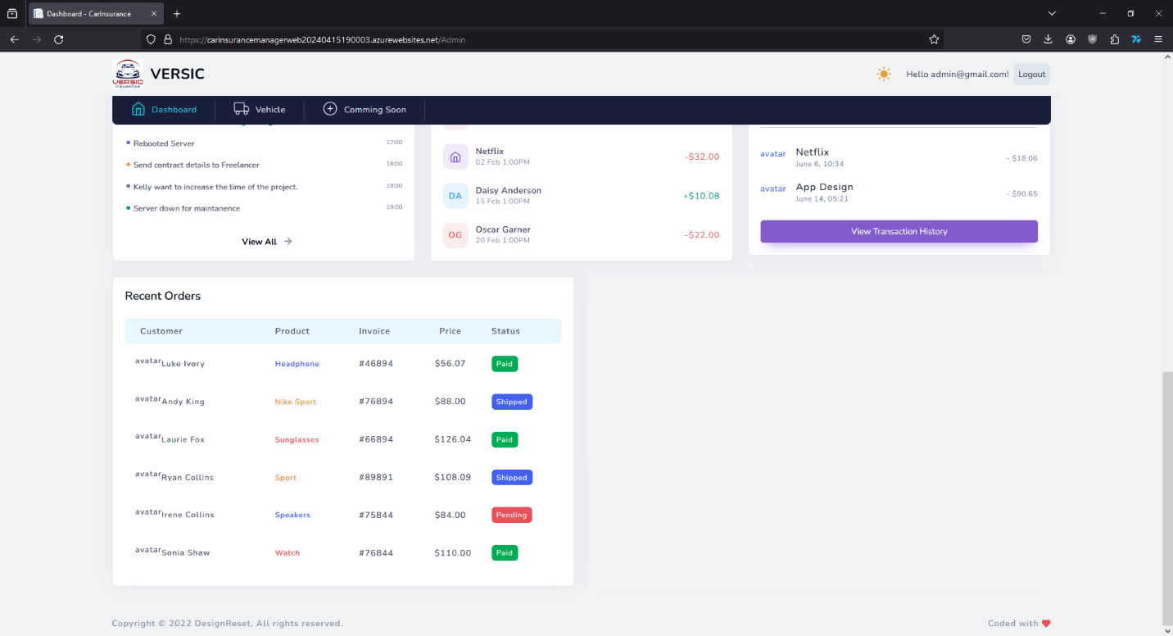

Main actions of the admin will be in the Tab “Vehicle”. Checking the vehicle list, manage types of Insurance, process the request, make the bill, check on the claim request,…

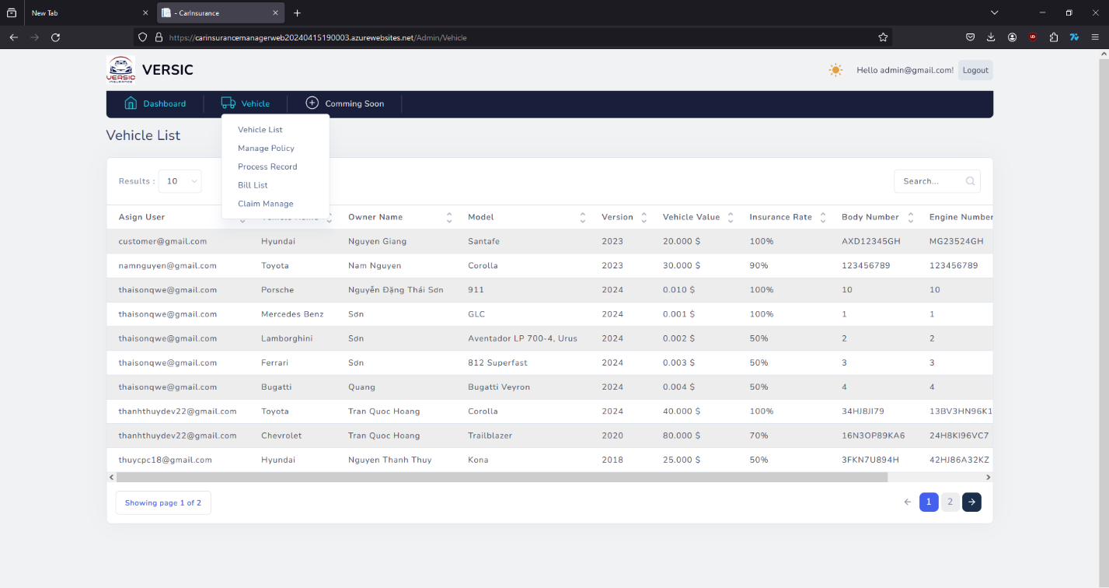

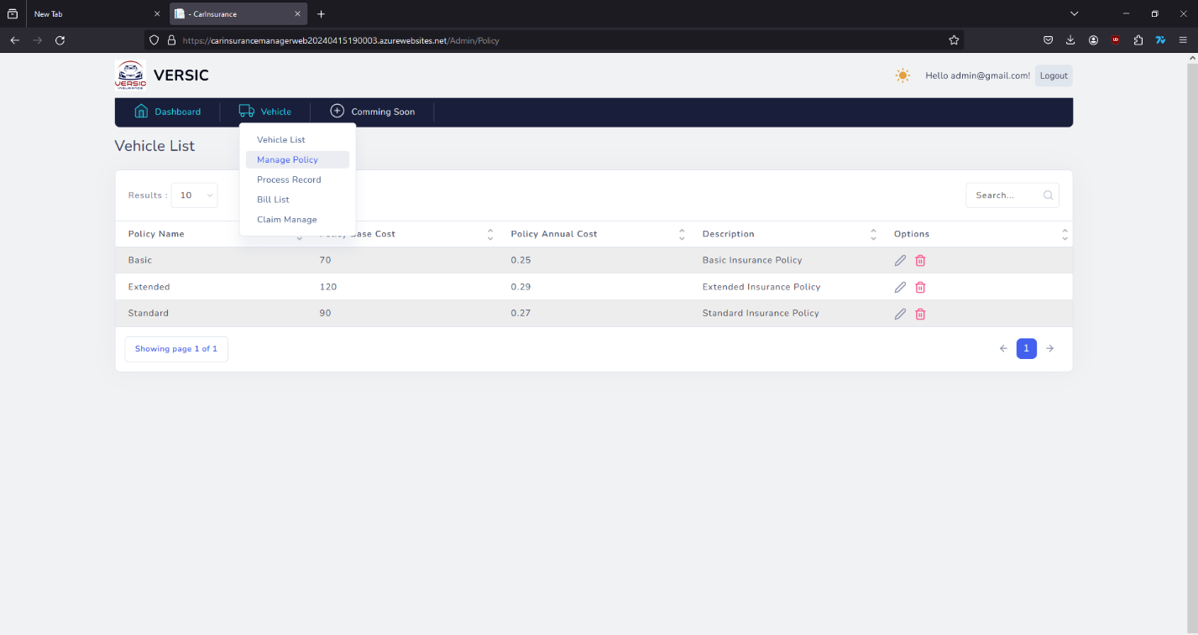

To process the buying request, admin go to “Process Record” and find the request to process.

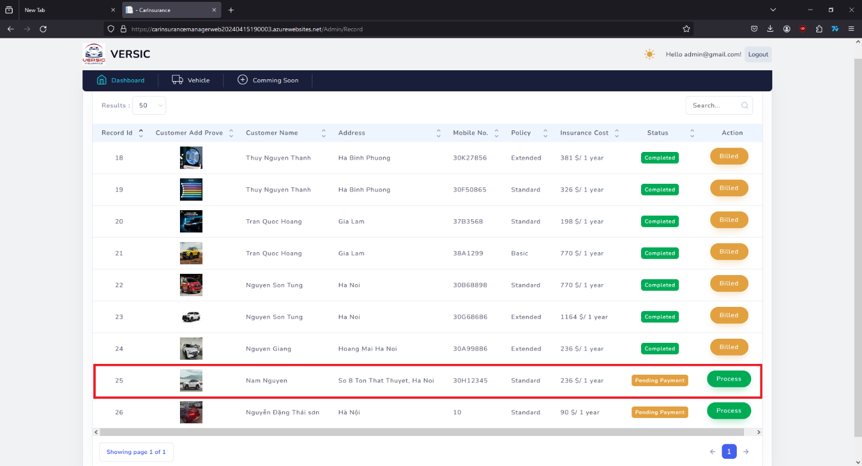

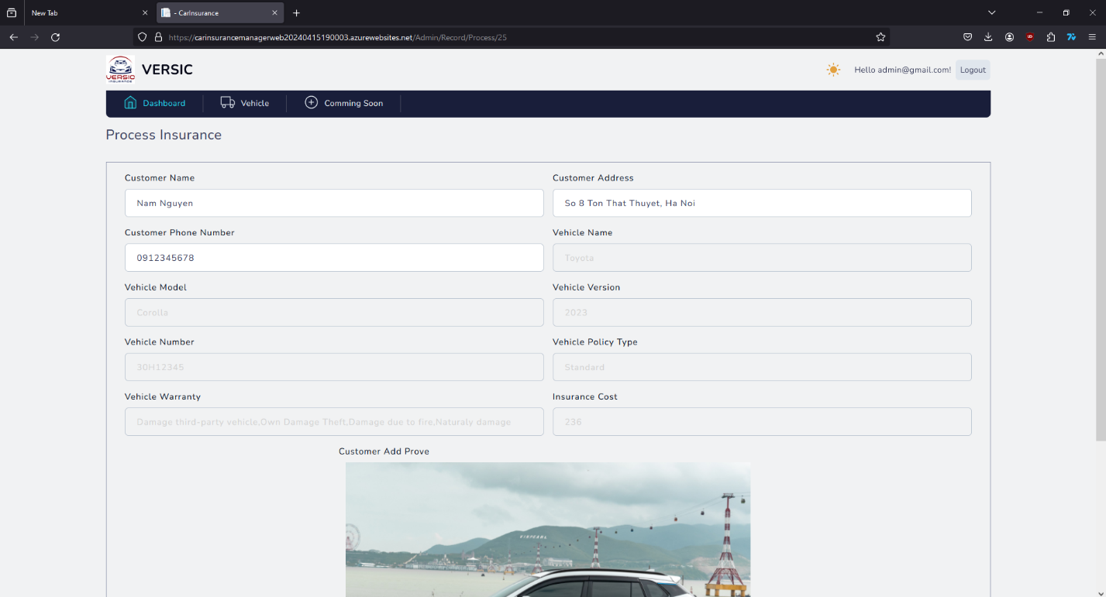

Checking the details of the vehicle then scroll down to “Payment status” and decide to choose which action need to be done.

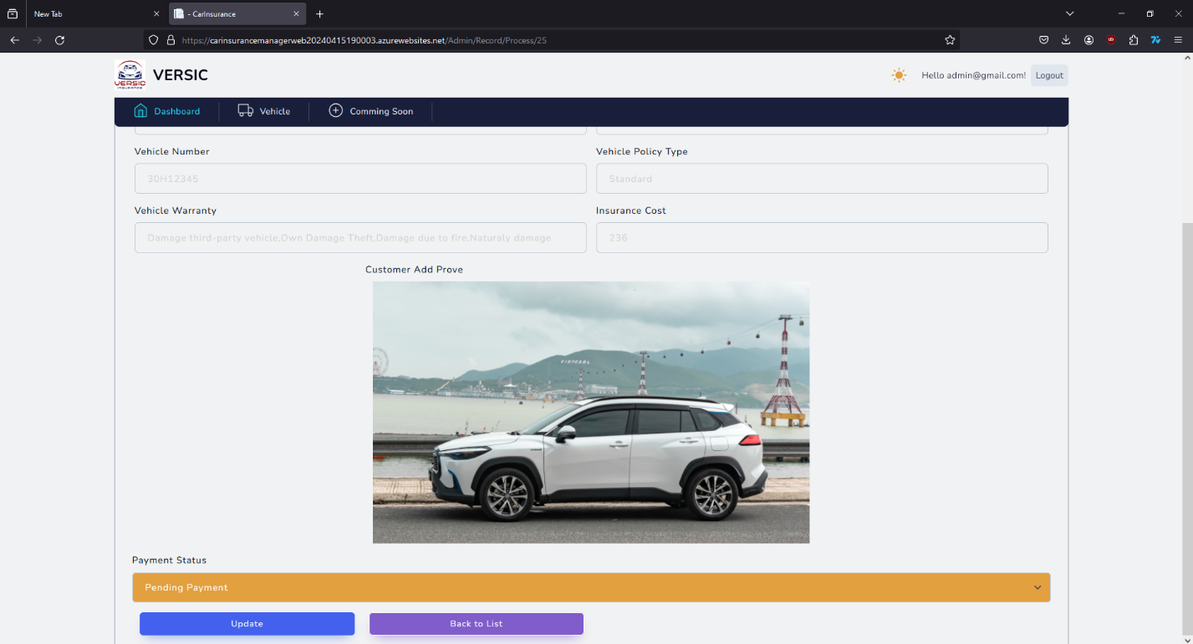

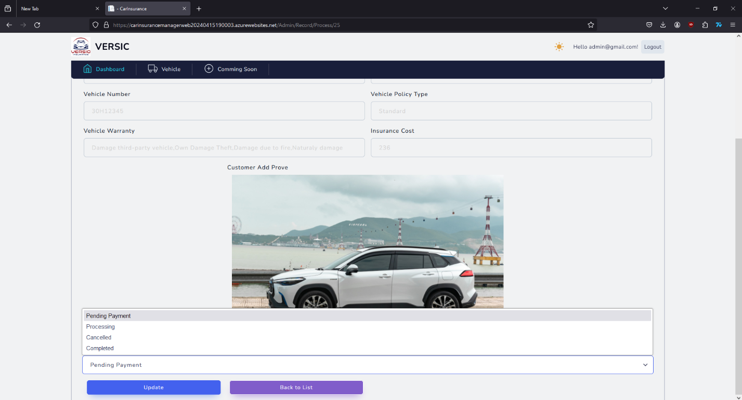

After change the status of the payment, press “Update” then the status will be updated.

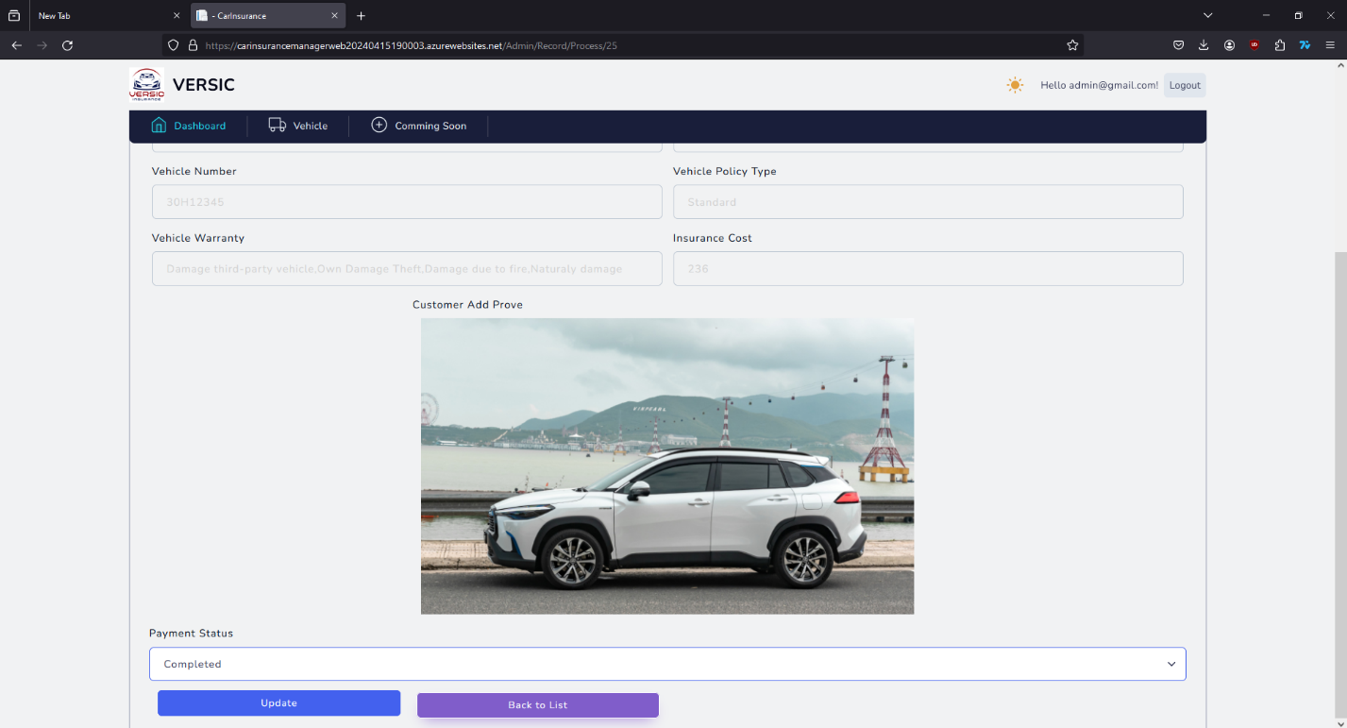

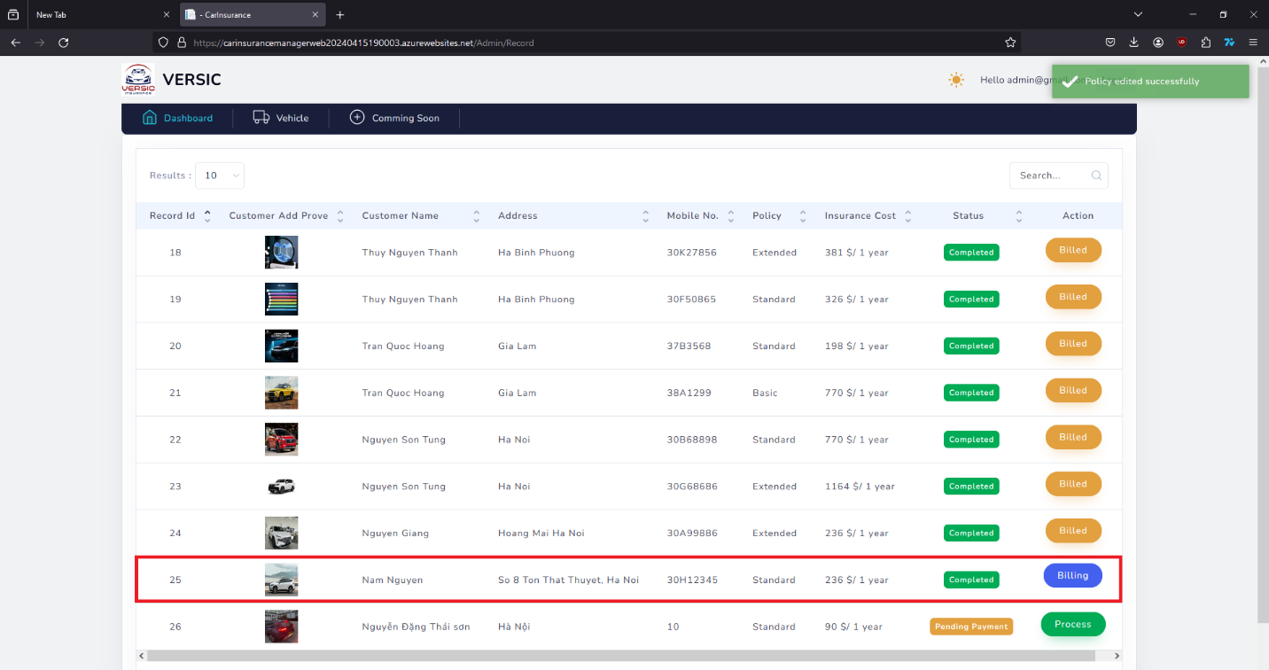

Admin can make a bill and send to the customer by press the “Billing” button.

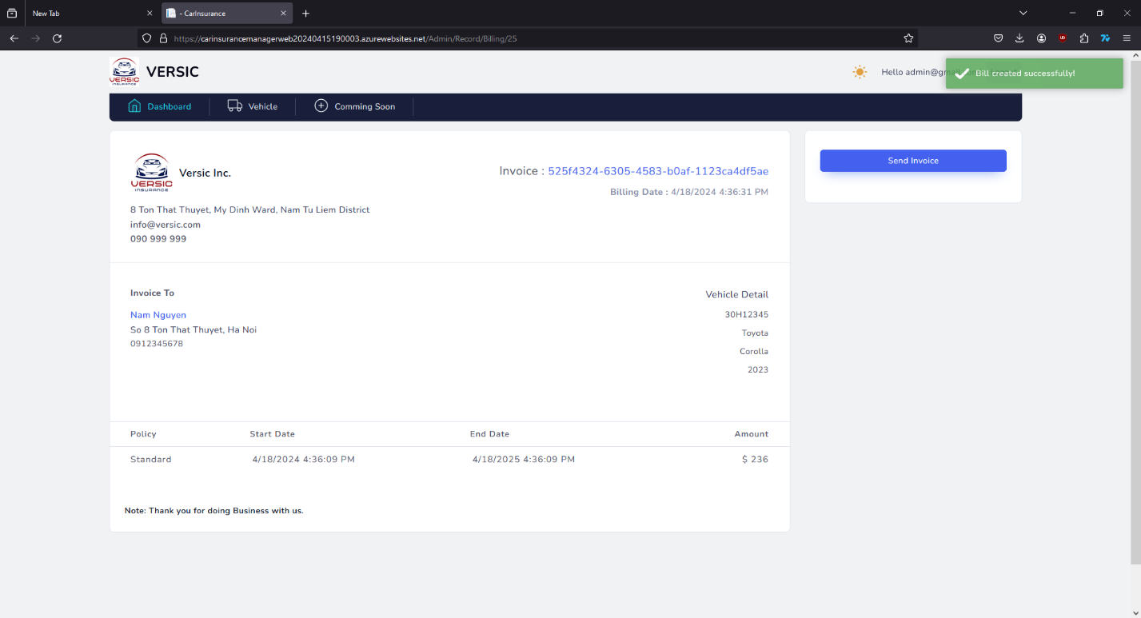

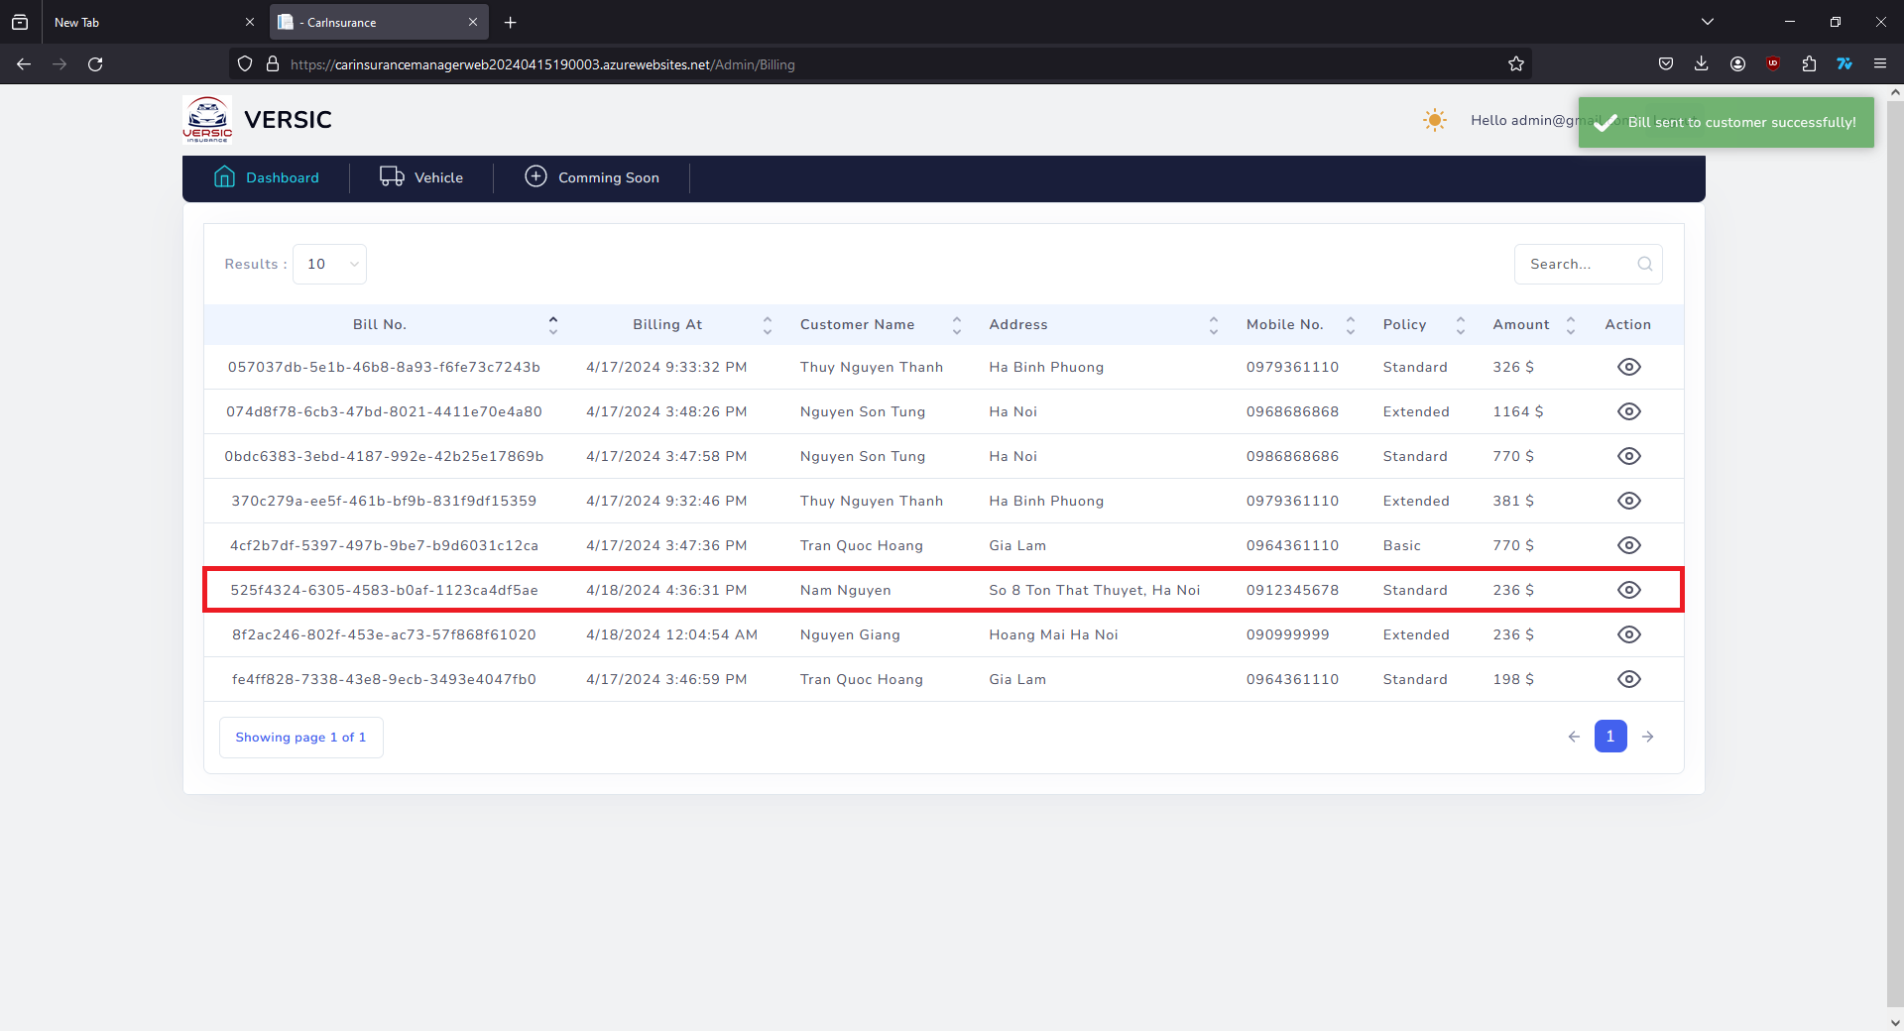

When Admin get a claim request from customer, Admin can go to the “Claim Manage” to take the action for the request.

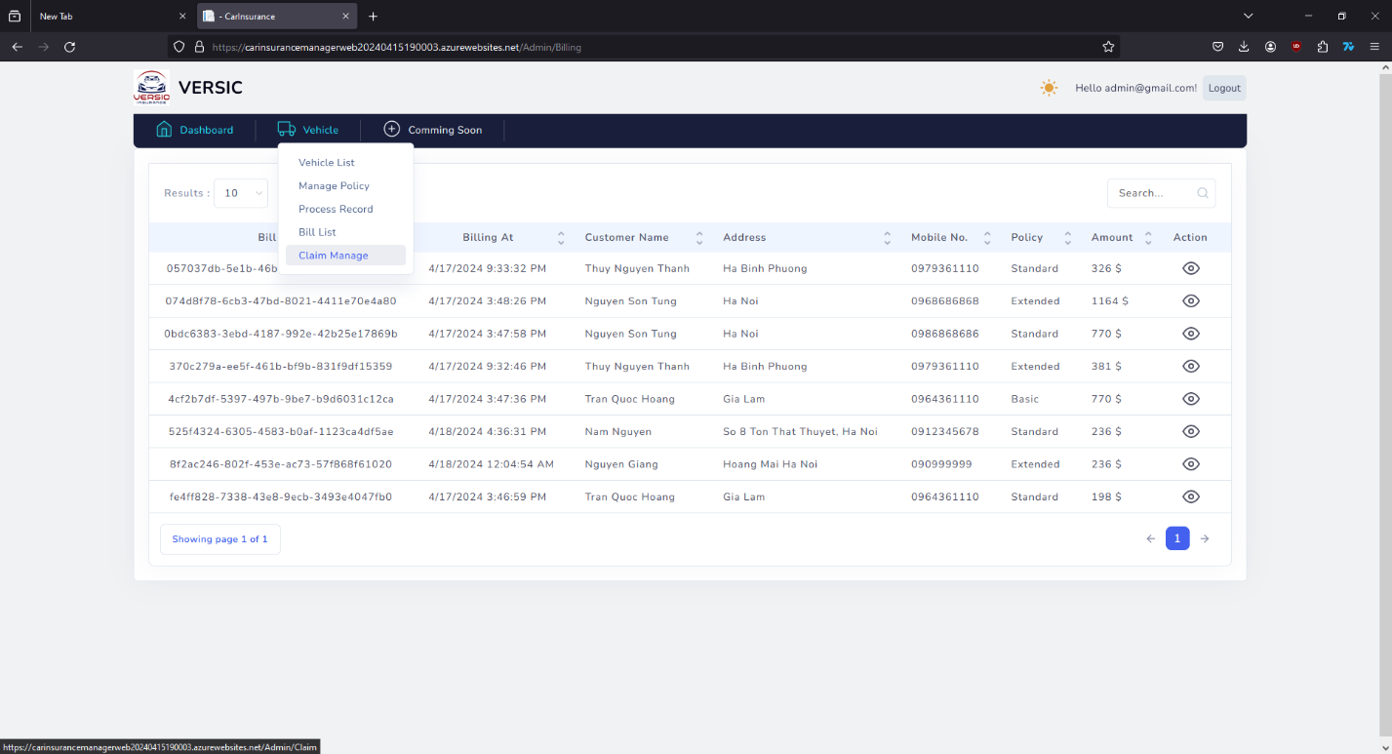

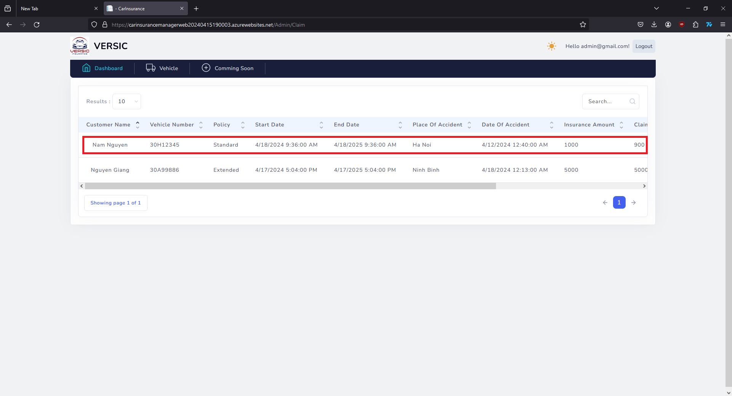

Admin find the request to process then press the button to working on the request.

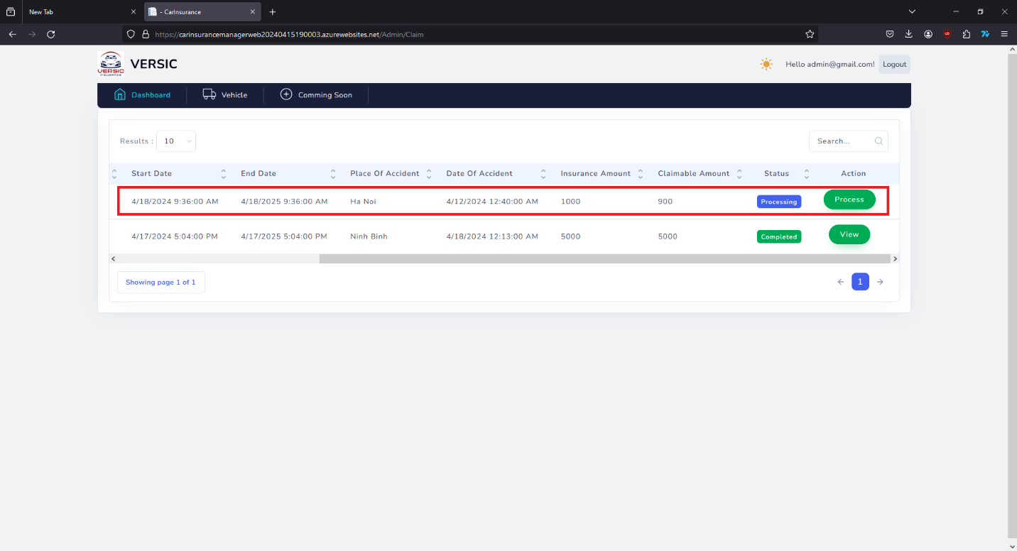

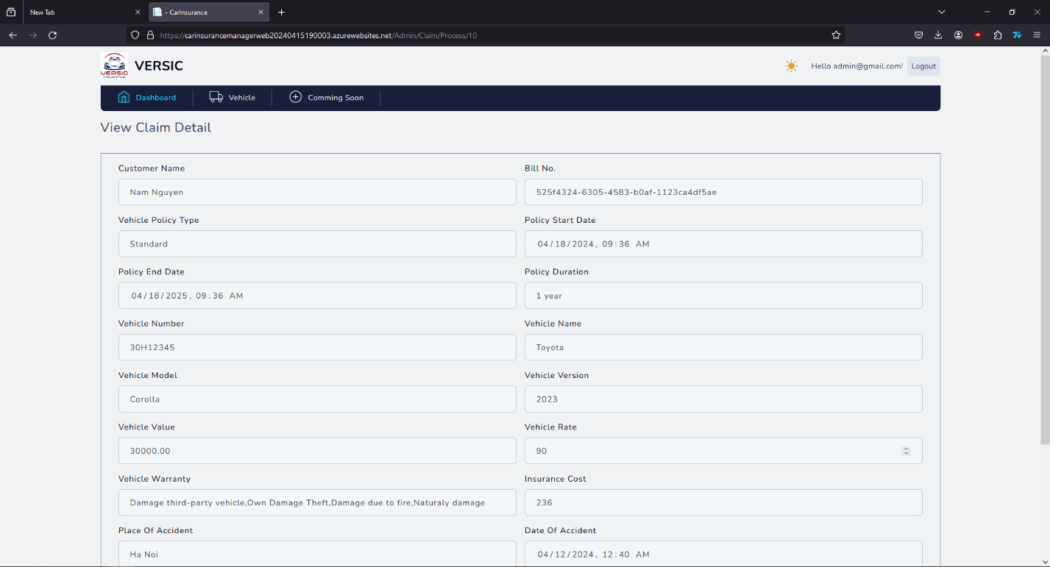

Admin will check on the information of the insured vehicle of the customer and decide to complete it or cancel it.

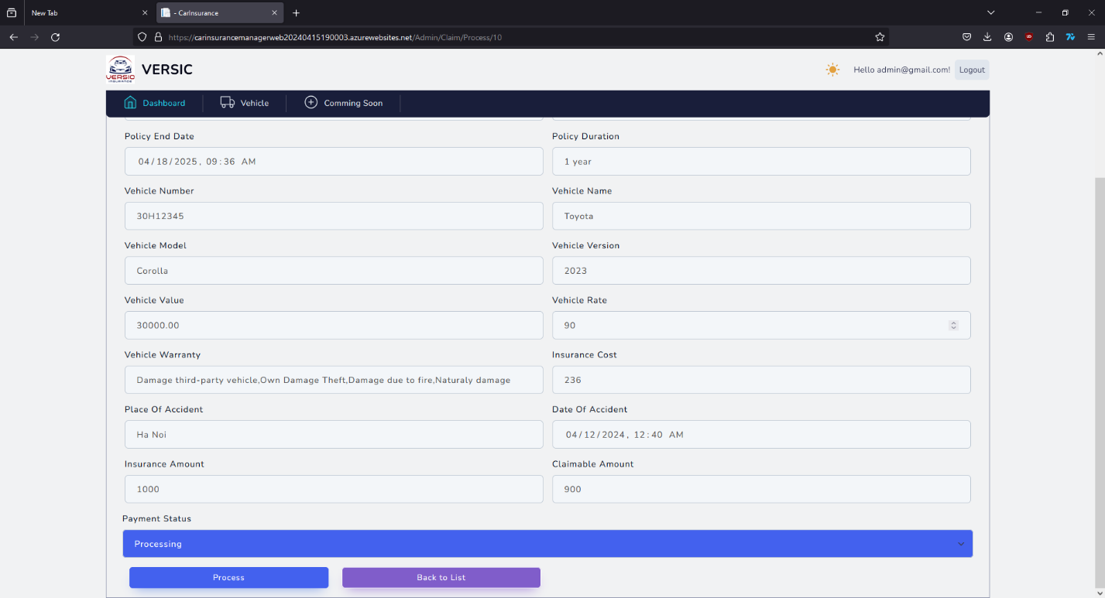

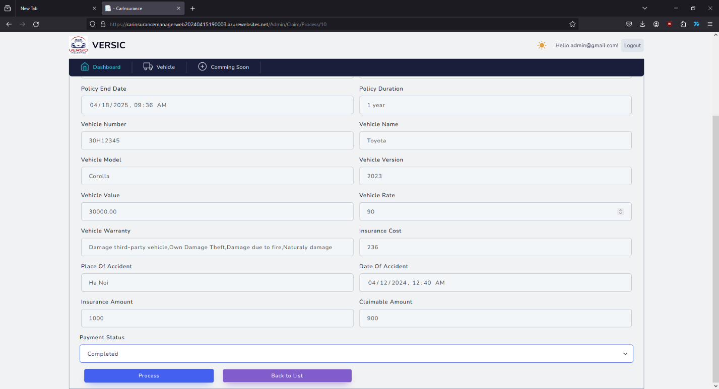

After decided action on the request press “Process” to update the status of the request.

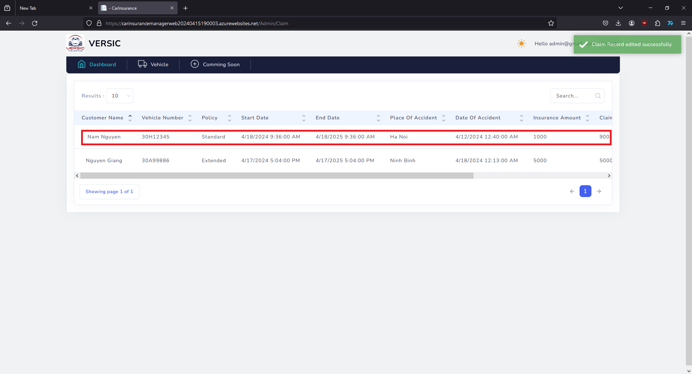

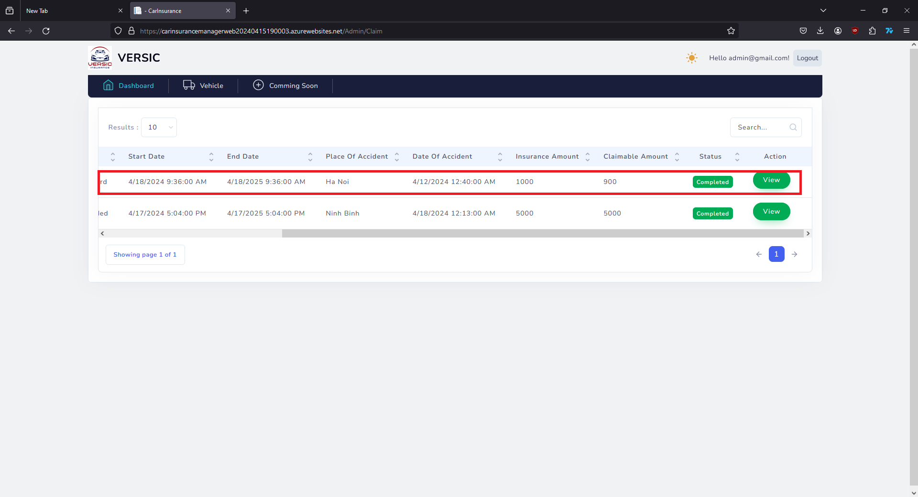

# Developer’s Guide

The solution name “CarInsuranceManager” has 4 projects:

* CarInsurance.DataAccess
* CarInsurance.Models
* CarInsurance.Utility
* CarInsuranceManagerWeb

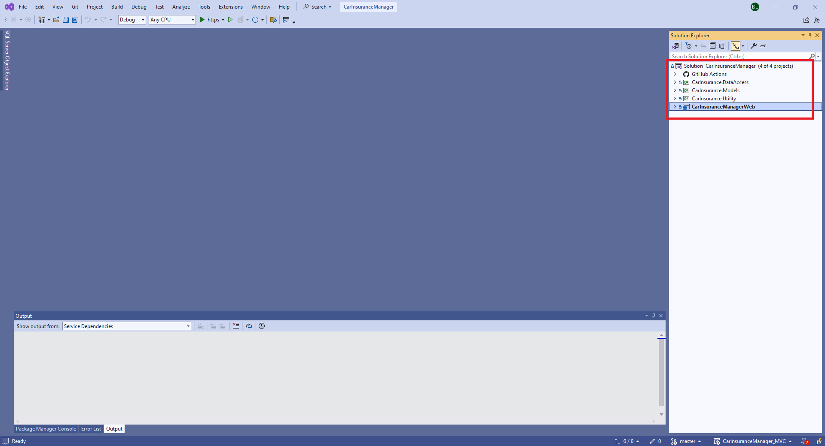

CarInsurance.DataAccess to communicate directly with Database SQL server.

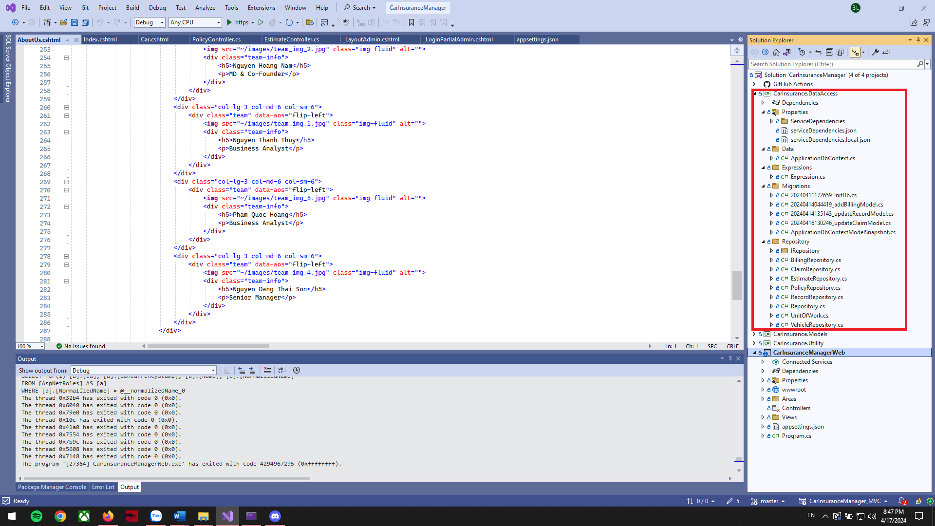

CarInsurance.Models has all the Models of the website.

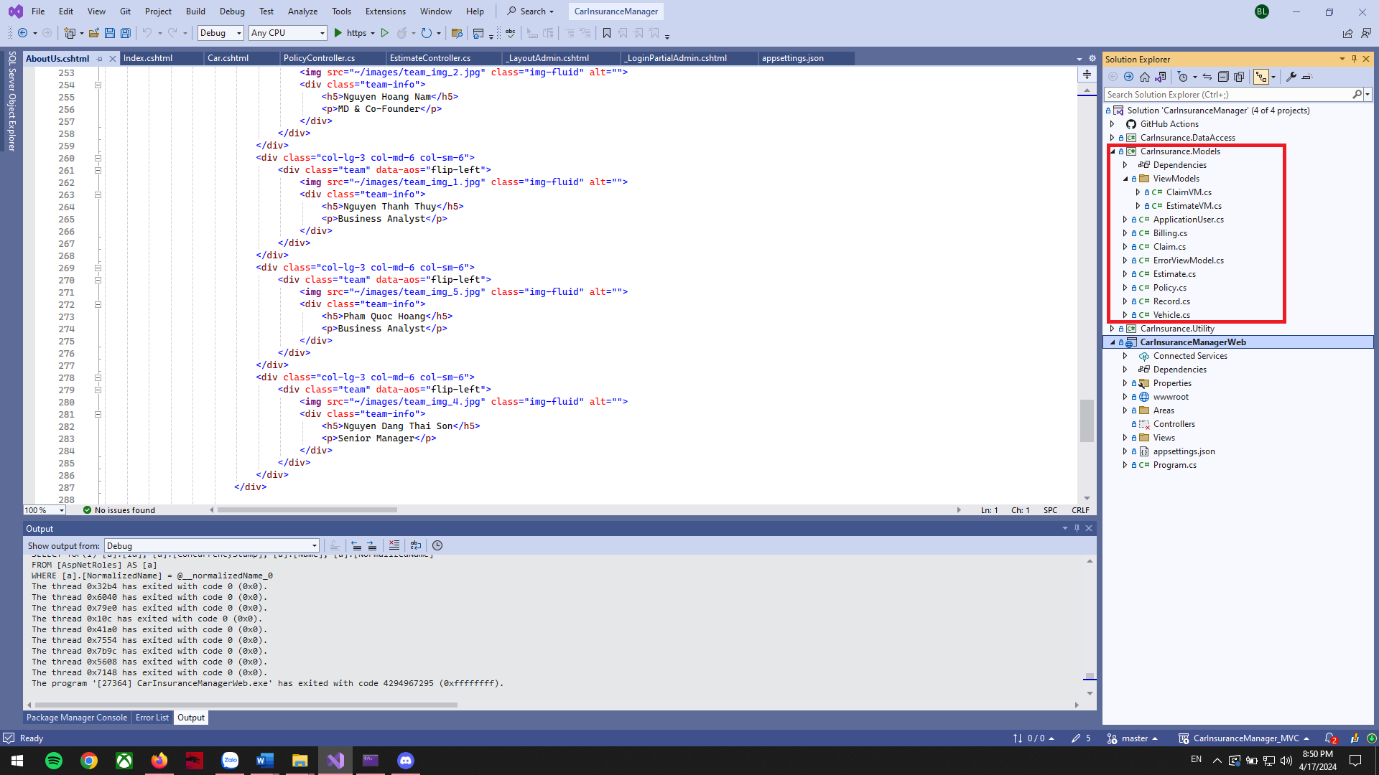

CarInsurance.Utility to contain other functions or dependencies such as sending email,...

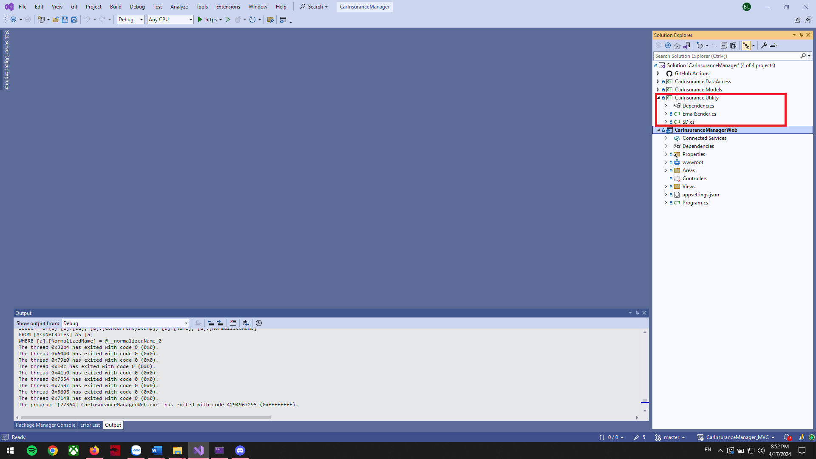

CarInsuranceManagerWeb is the main thing that contains controller to direct user requests and query data from the database via CarInsurance.DataAccess.

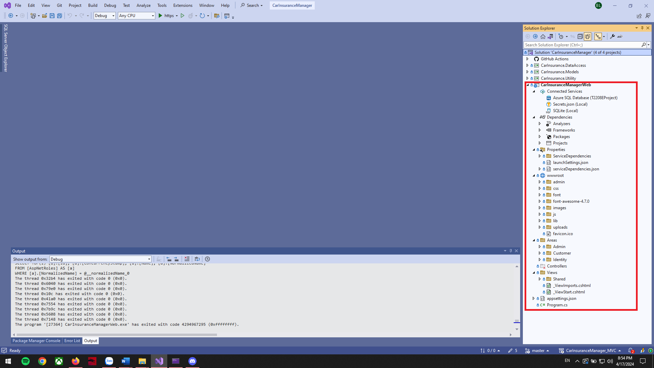

# Check List

|  |  |
| --- | --- |
| Design use-case diagrams | ✓ |
| Design workflow for project | ✓ |
| Create project, project file structure, readme | ✓ |
| Adjust the interface of Home, About Us, Contact | ✓ |
| Design Logo for website | ✓ |
| Design database schema, diagram for project | ✓ |
| Decide algorithms and calculation formula | ✓ |
| CRUD for Policy | ✓ |
| Adjust the interface of Car page | ✓ |
| Add features to add, edit, delete | ✓ |
| Add features Login, Register | ✓ |
| Estimate car insurance price depends on vehicle value, vehicle rate, policy base cost, policy annual cost | ✓ |
| Create a list of car brands and car types | ✓ |
| Deploy database to Azure | ✓ |
| Save policy records to the database, display customer records on the front-end and back-end | ✓ |
| Create bill after payment, Save bill to DB | ✓ |
| Create a claim-record, save it in the database, display the claim record on the backend, front-end | ✓ |
| Deploy project to Azure | ✓ |
| Design slide for project | ✓ |
| Write documents for the project | ✓ |
| Demo 20 records for website | ✓ |
| Video demo project | ✓ |

# Acknowledgments

We would like to thank our Mentor Mr. Hà Việt Sơn for his guiding role, wise counsel and vision in the creation of this website.

Many thanks as well to the team members, this website would not be able to be done without them, Nguyễn Bắc Giang, Phạm Thanh Thủy, Phạm Quốc Hoàng, Nguyễn Hoàng Nam, Nguyễn Đặng Thái Sơn.

|  |  |  |
| --- | --- | --- |
|  | Team member | Task |
| 1 | Nguyễn Bắc Giang | Main theme, Features, Functions, Modules, Deploy to Azure, Scripts, Database, Debug, Team Coordinator. |
| 2 | Nguyễn Thanh Thủy | Use-case diagrams, database schema, diagrams for project, Testing, BE. |
| 3 | Phạm Quốc Hoàng | Logo, Home page, About us, Products, Product details, Data (car list). |
| 4 | Nguyễn Hoàng Nam | Documentation, Guide, Video Demo, Slide, Contact us, Location, FAQ, Interface, Tester, Debug, Team Support. |
| 5 | Nguyễn Đặng Thái Sơn | Testing, support. |